|  |
| --- |
| UNIT 37 |
| Assignment – 3  2D ANIMATION |

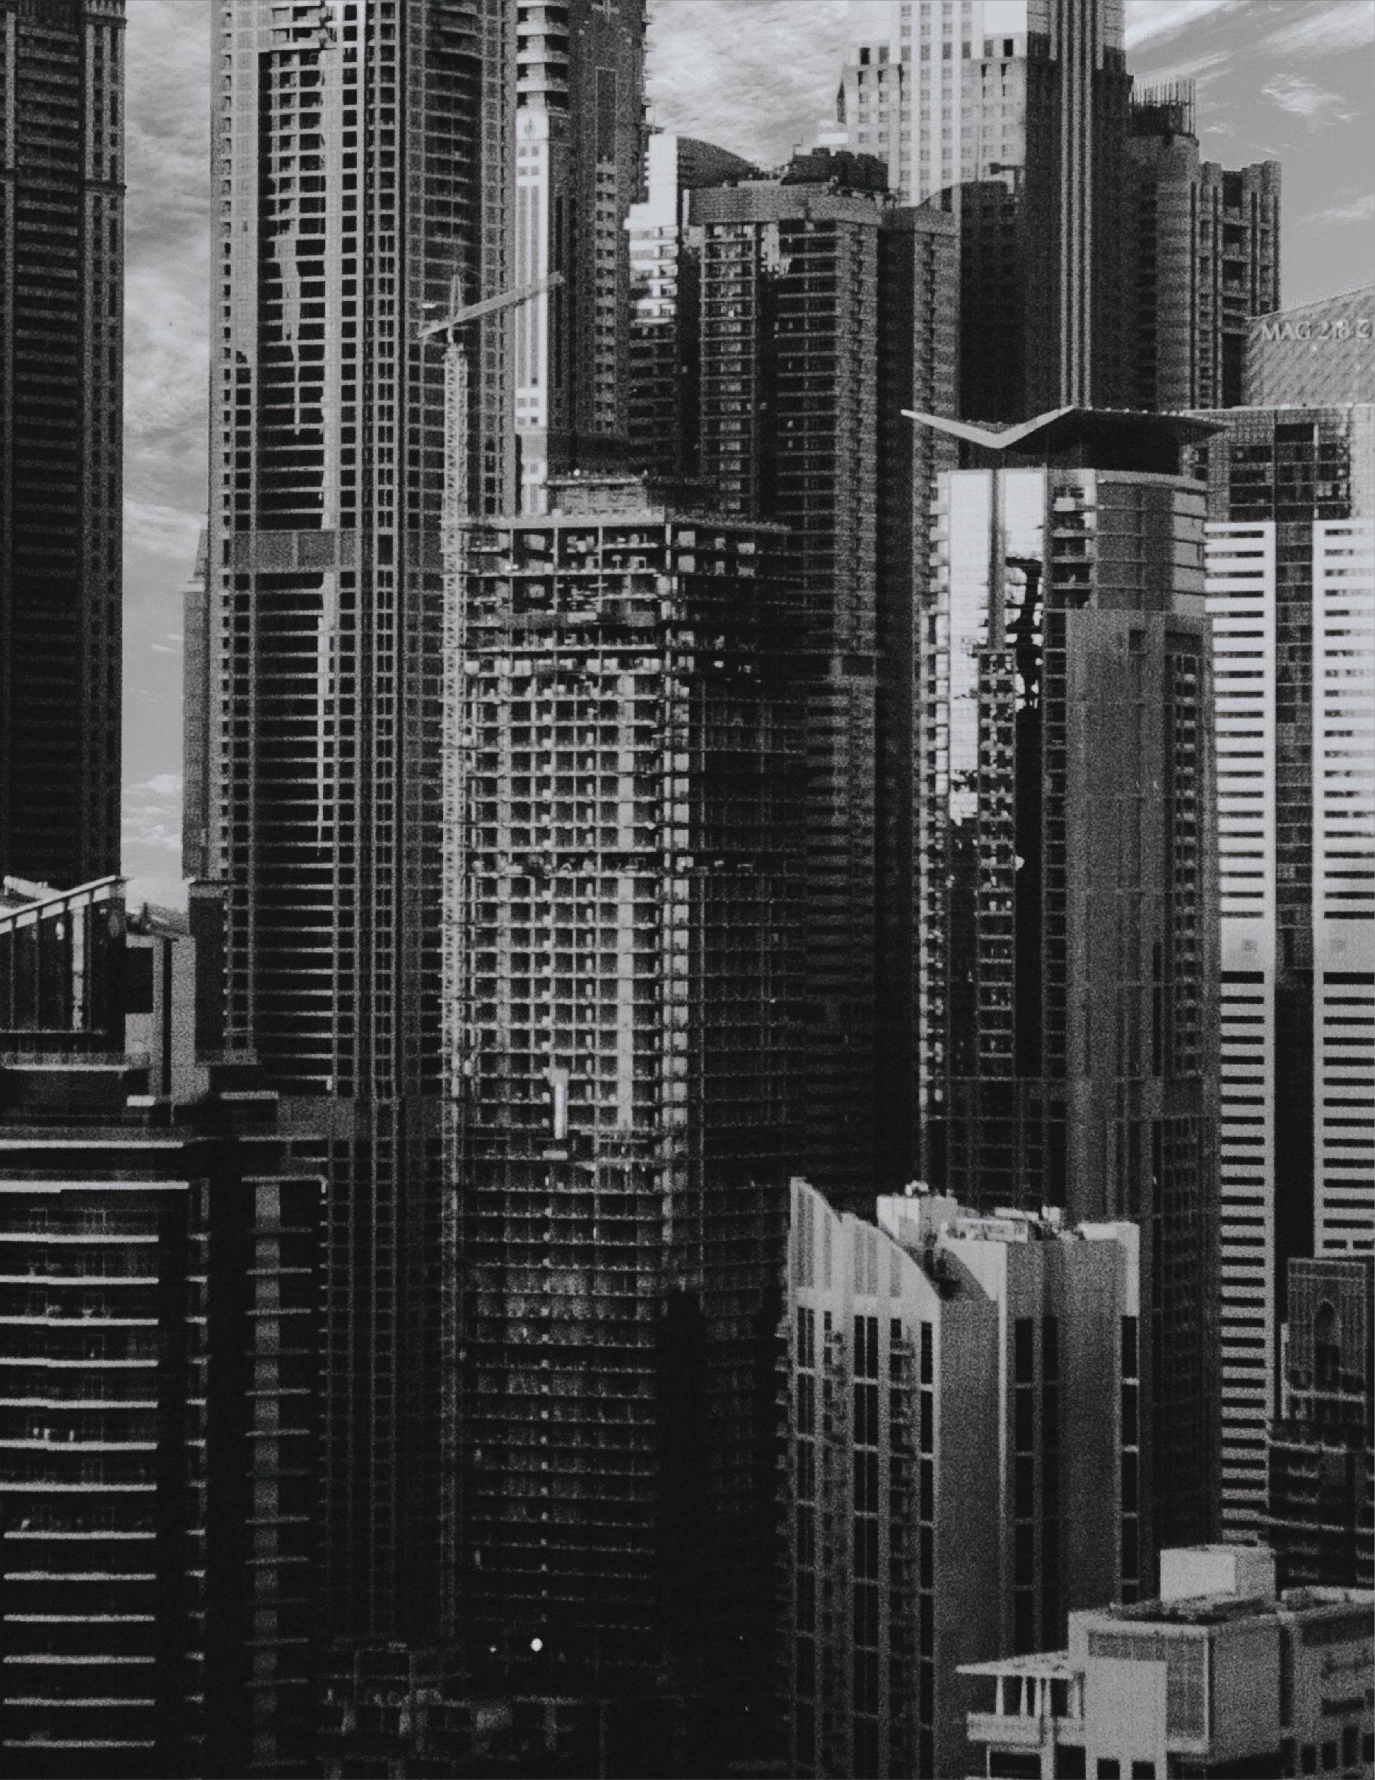

Dhruv Joshi

ID: 653871

**Table of Contents**

TASK 2 2

PRODUCTION LOG 2

TASK 2

PRODUCTION LOG

**Select information to support a business**

## TASK 2

### PRODUCTION LOG

The production log is my documentation linked to how my animation was design and developed, conveying major areas and components that defined and refined the development and deployment of the animation. My production log will consist of a documentation linked to the production, and it will be full and detailed, along with containing, conveying and evaluating the production management and scheduling of the animation, with detailing how the following workload was conducted, with points that discuss its effectiveness, consistency and portraying the use of techniques and conventions being carried out in a professional manner.

Just like any other animation, the starting point of designing and developing the animation, is to select the format, size and category of the canvas appropriate for the context. Therefore, to start off with my animation, I had selected the “HD” (1280p x 720p) canvas, set the environment in 30 fps and chose the platform as “Action Script 3.0”, since it was the default platform of Adobe Animate, and here it’s how it was done:

1. First of all, open the animation software package, as for the development of my animation I am using Adobe Animate. After opening the software, click on “Create New” in the left corner of the application:

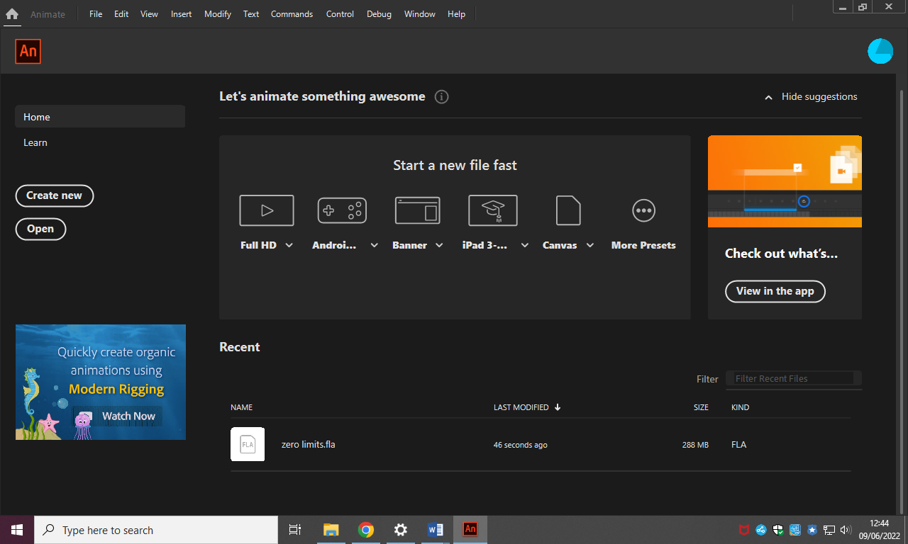

1. Afterwards, select the “HD” (1280p x 720p) canvas, then set the environment in 30 fps and choose the platform as “Action Script 3.0”, since it is the default platform of Adobe Animate. After selecting all of the following, hit “Create”:

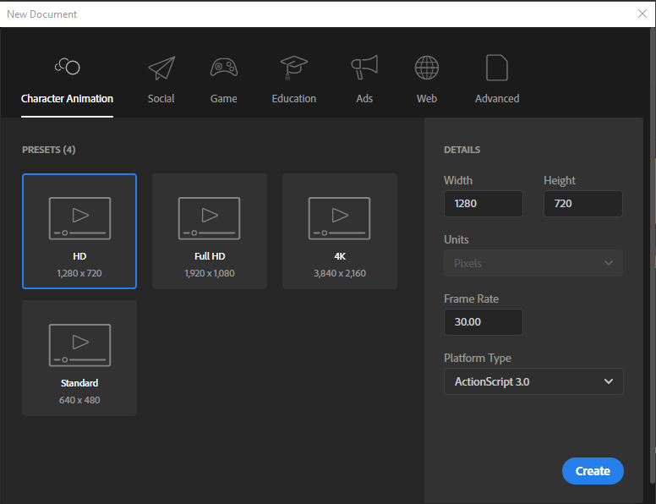

Here’s the canvas:

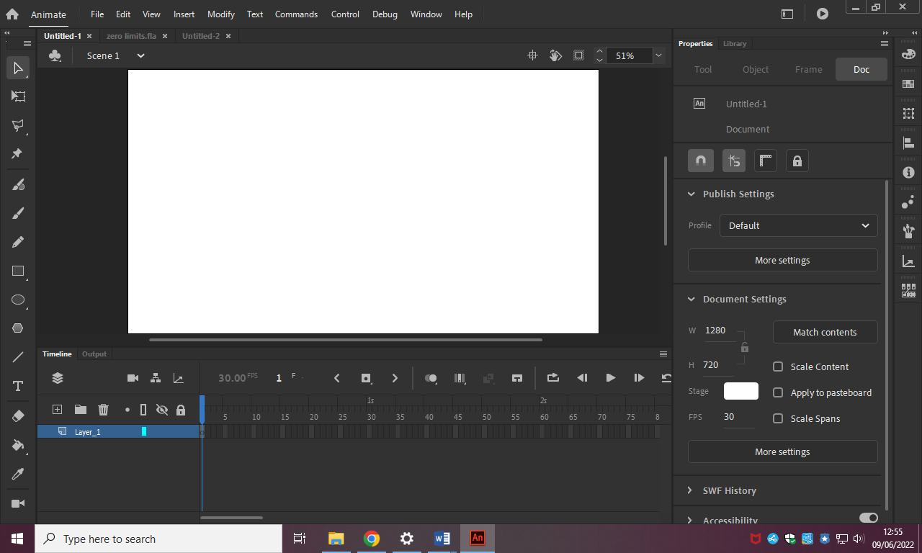

Afterwards, I started populating the blank animation canvas with layers, which stand for different stages as developed in my storyboard of my animation. This is how it was done:

1. Click the “New Folder” button in the bottom-left section of the application. And create as many layers as you have stages on your storyboard. I have clicked the button 13 times because my animation storyboard contains 12 stages, including introduction, therefore I made 13 folders in my animation:

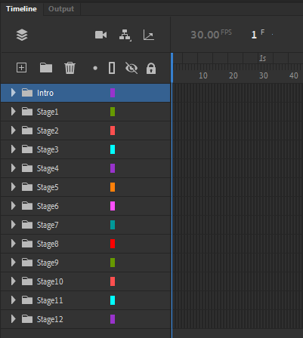

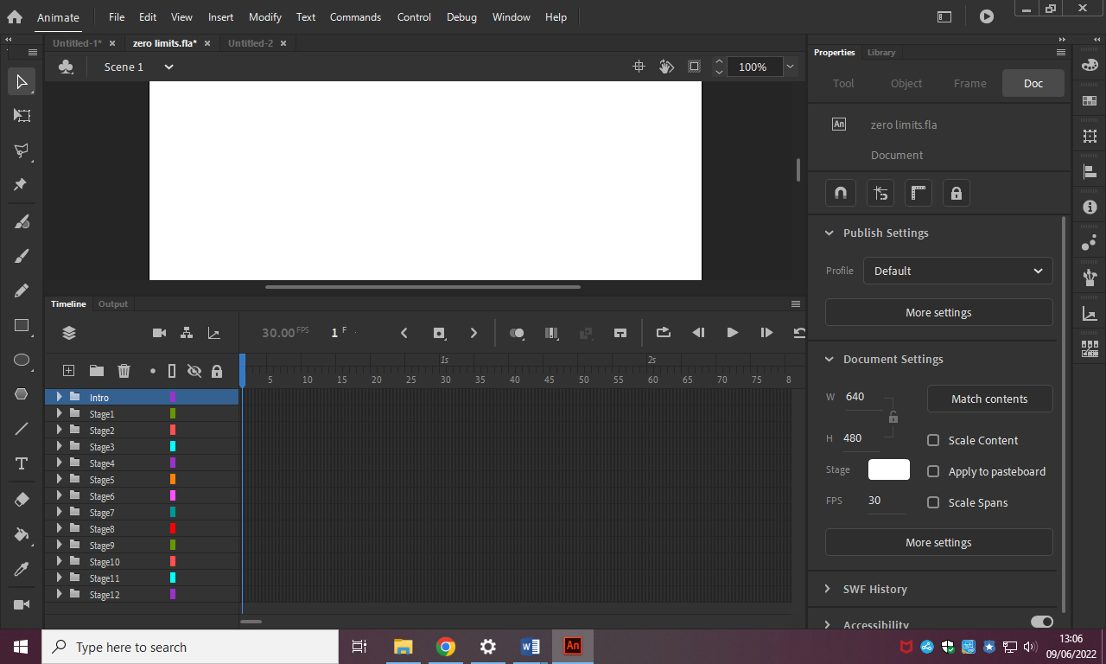

1. Afterwards, arrange the layers in an ascending order, to make it easier for developing and managing layers. And rename the folders as follows, change the name of the folders to “Stages”, and in the ending of it add a number which corresponds to the order of the folders. For the first folders, name it as “Introduction”, if your animation includes introduction:

I started creating my first stage for the animation, which was the introduction, and these are all the steps that followed in the development of it:

1. Change the background color of the canvas to “Black”.

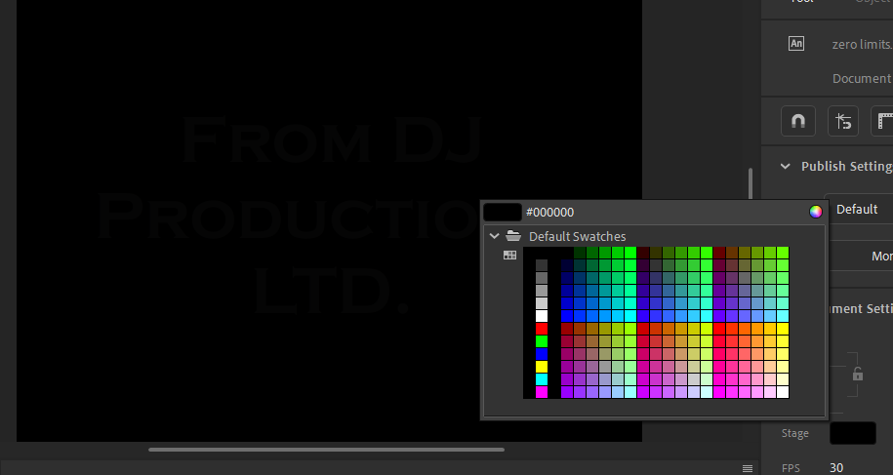

1. To add introduction credits, choose the “Text Tool” from the left toolbar and insert it anywhere on the canvas. Type in the introduction credits you desire to add inside the introduction, inside the Text box, in my case I have added “From DJ Production LTD.”. After adding the text, change its size and font from the “Object” tab like so:

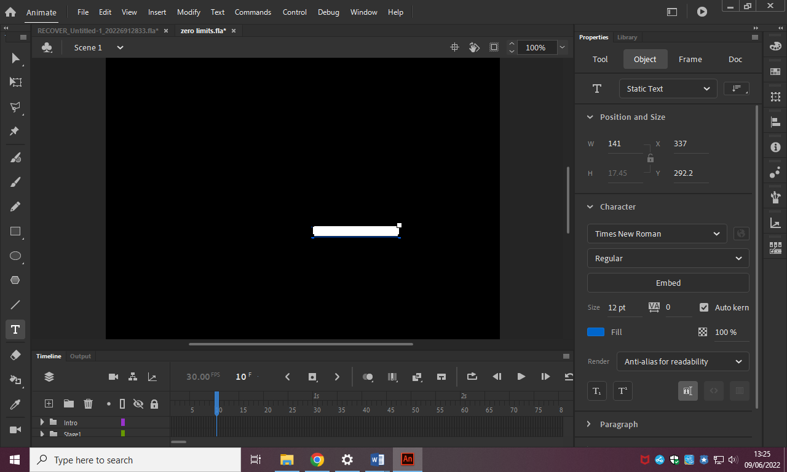

1. Then position the text box to the center of the frame and complete the first Introduction credit as so:

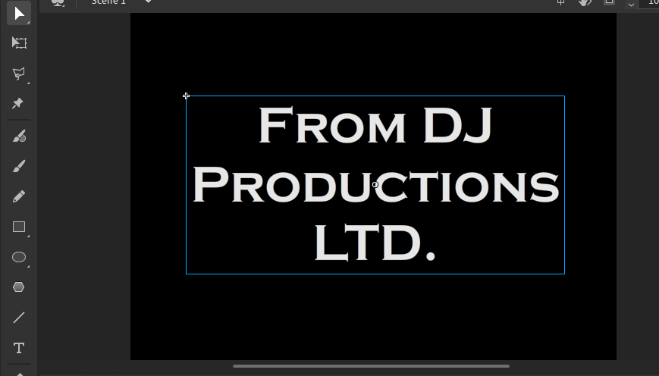

1. Repeat the process for the second Introduction credit. For my animation, the second introduction credit is “A Dhruv Joshi Movie” showcasing the production house and the animator of the animation before the animation has stared.

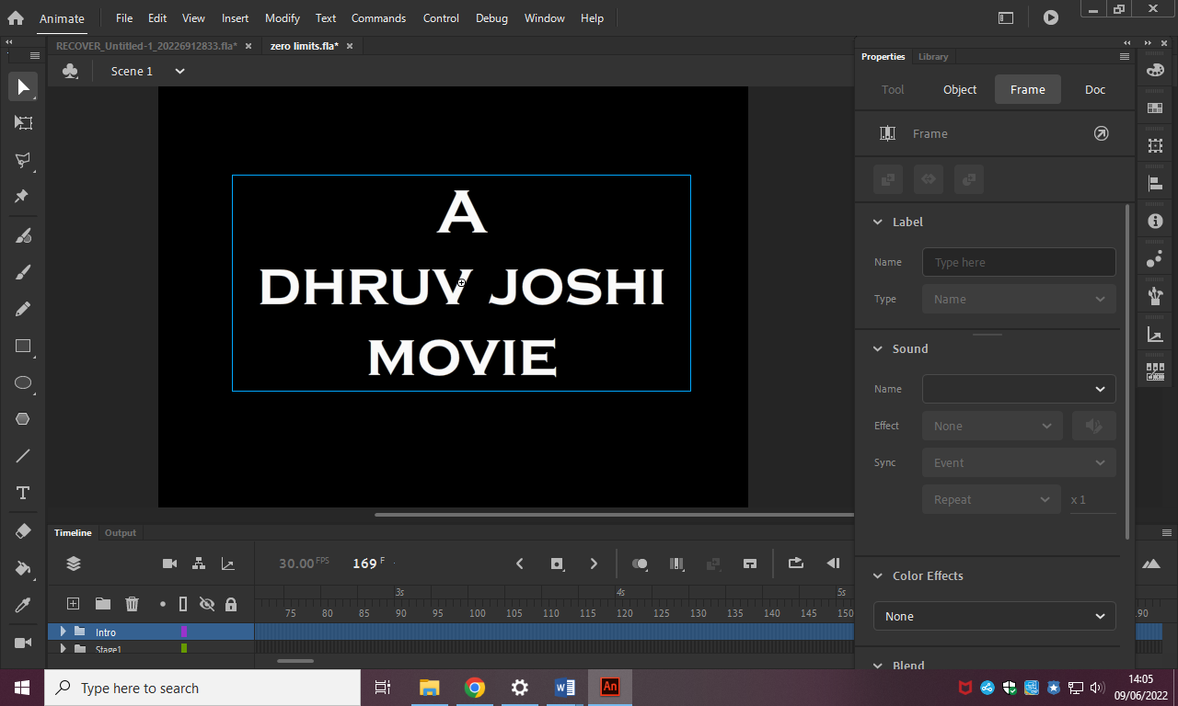

1. To animate the introduction credits, I decided to implement the fade-in and fade-out effects to the credits, and here is how I did it: Right-click on the text box and click the first option which is “Create Classic Tween”.

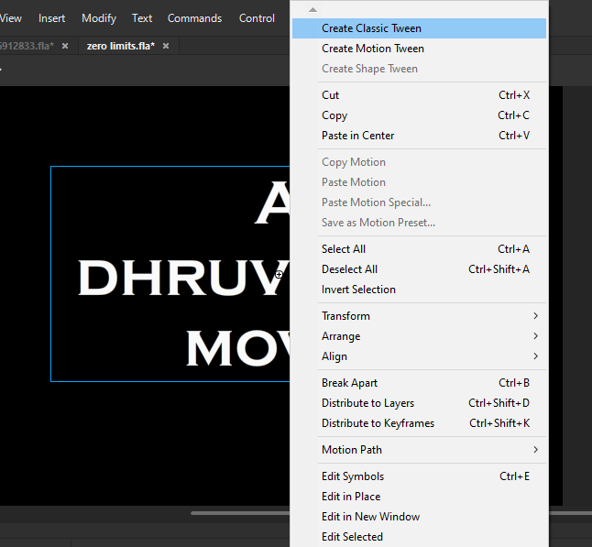

1. In the timeline, extend the classic tween from the beginning point to forwarding it by 2 seconds by inserting keyframe after a 2 second gap like so:

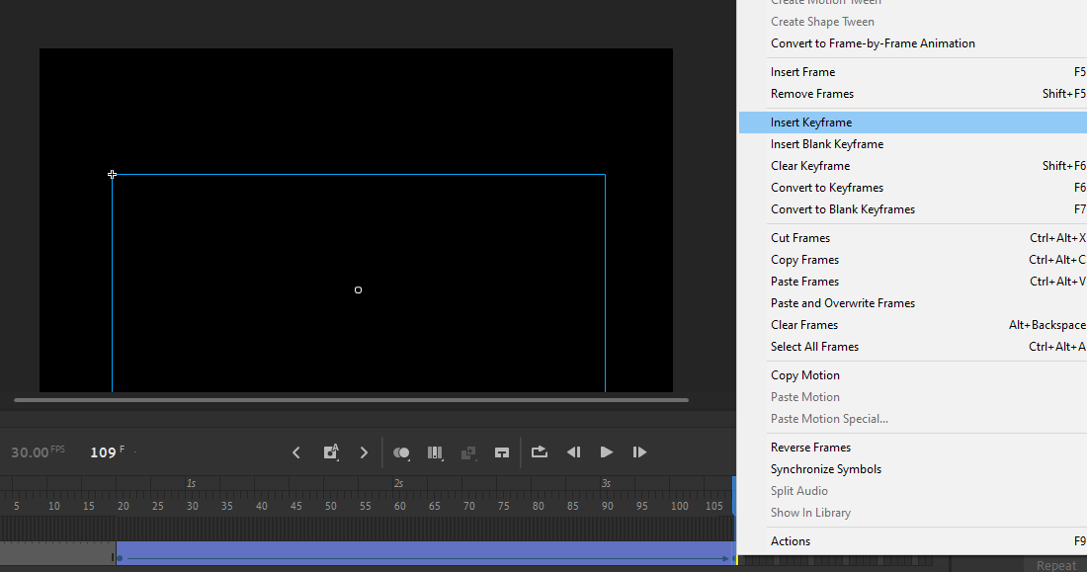

1. Afterwards, in the middle of the following classic tween, add another keyframe to divide the frame into 2 parts like so:

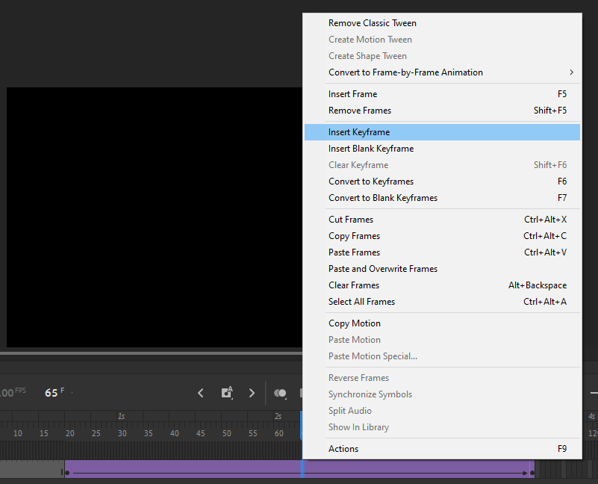

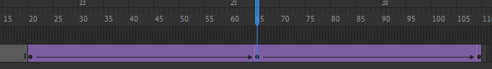

1. In order to add fade-in fade-out effect using classic tween, select the 2 end-points of the frame, and go to the “Properties” section, where you will find the “Frame” tab. In the following tab, go to the “Color effects” section, in its drop-down bar select the “Brightness” property, and set the “Bright” value as -100%. Whereas in the middle of the frame the division has occurred in accordance to the steps above, set the “Bright” value as 100% instead. This procedure will make the text, from having no brightness, gradually increase its brightness as the time goes by, where it will reach its maximum in the middle point of the frame, and afterwards, the value of the brightness will start losing again, towards going fully black.

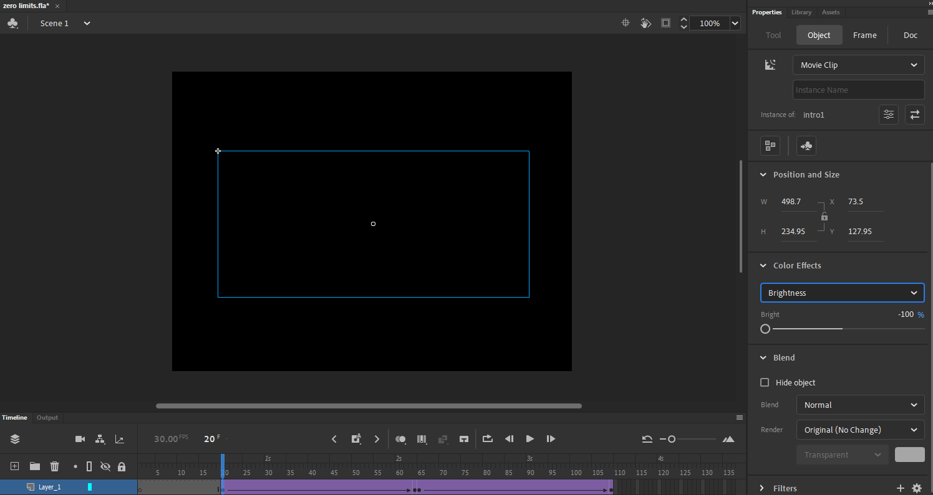

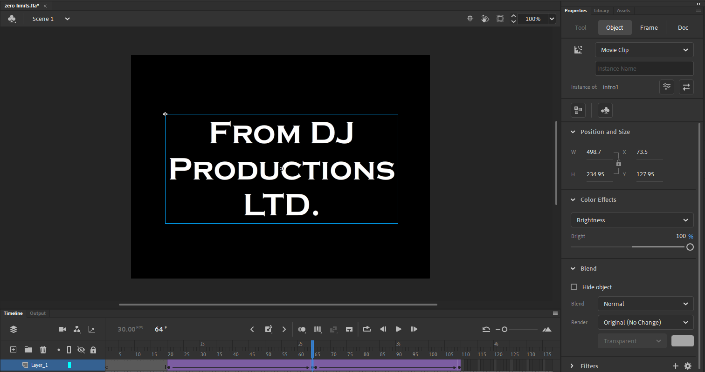

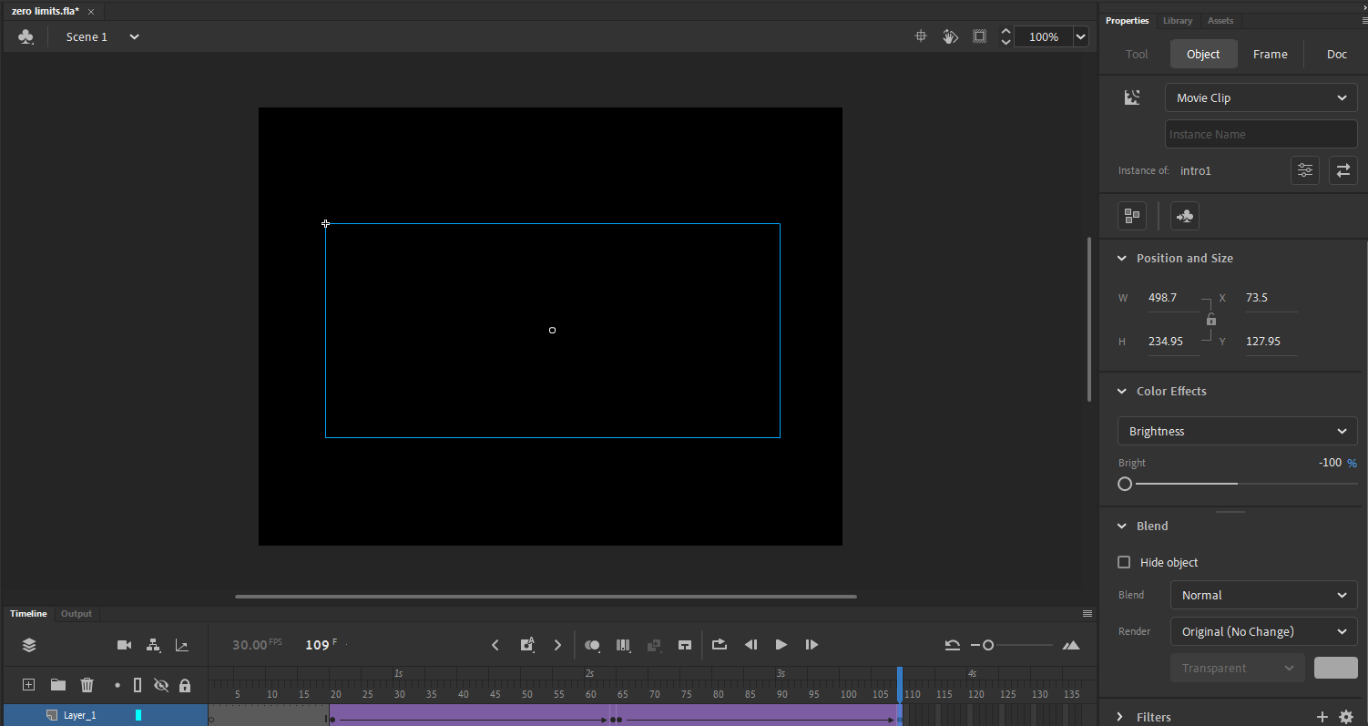

After successfully implementing and learning to implement the following procedure, repeat the procedure with the second introduction credits.

Afterwards, for the introduction to be more entertaining and interactive. I added special effects with cars displaying the title of the animation. In order to implement this, here’s the procedure:

1. Firstly, bring all the assets made in the design phase of the animation into the table. Therefore, to add my first special effect, I am using the following 2 cars, smoke and the animation title.

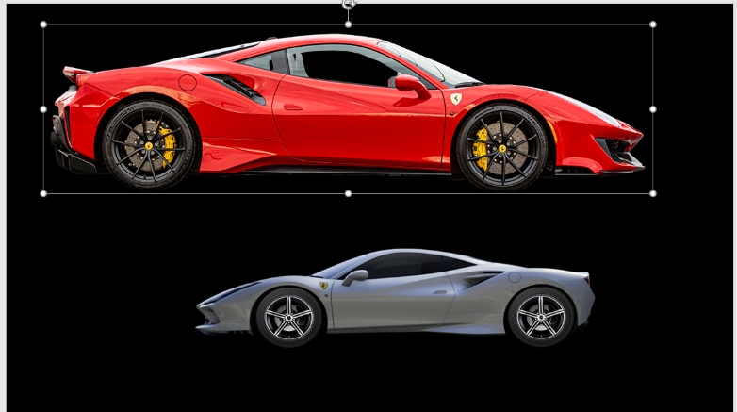

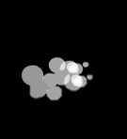

1. Then, insert the car and make it follow the smoke flair as so, into the animation to the appropriate position, it is ideal to implement both of the elements before the canvas. Do the same with the silver car.

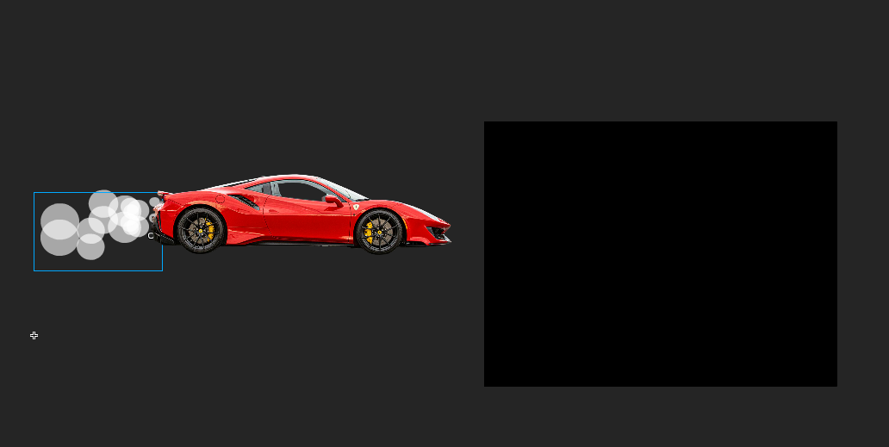

1. Using classic tween, make the first car go from the left to right, and the second car from right to left. And then add the title of the animation in the middle of the canvas. Using classic tween, add the same fade-in fade-out effects as you added in the introduction credits to the title of the animation, but implement the following after the two cars are gone from the canvas. Here is how the end result looks like, and that marks the completion of the introduction:

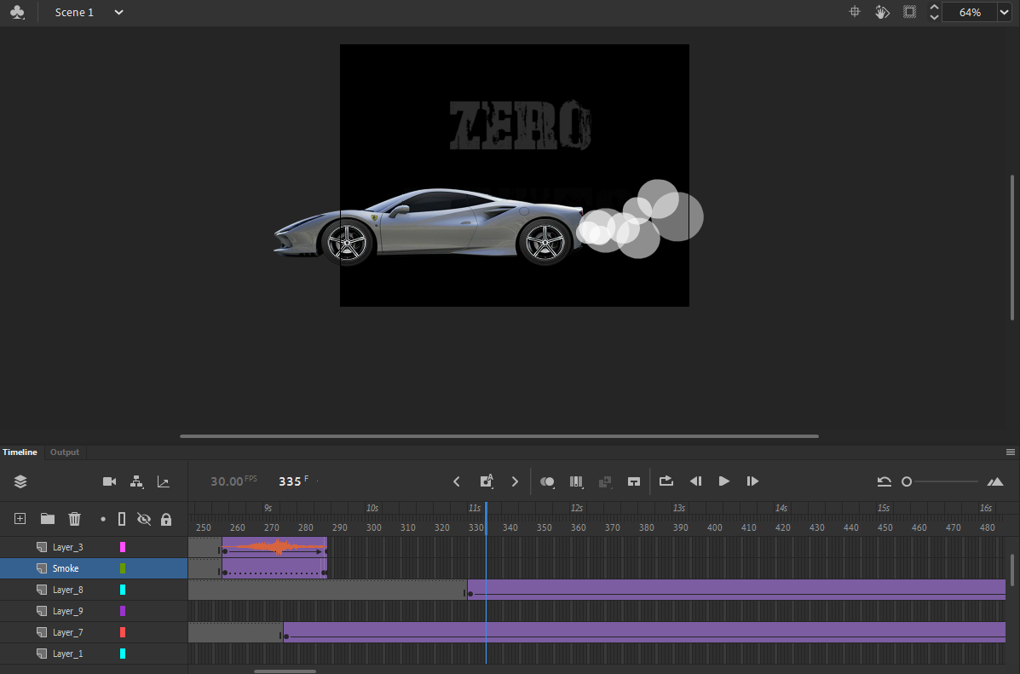

To add audio into the introduction, add a new layer inside the introduction folder and make I keyframe to be as long as the length of the introduction. Then follow the following steps on how I added the sound:

1. Firstly, open the “Library” tab of the top-right corner, and using file explorer, drag and drop the sound file into the library as so:

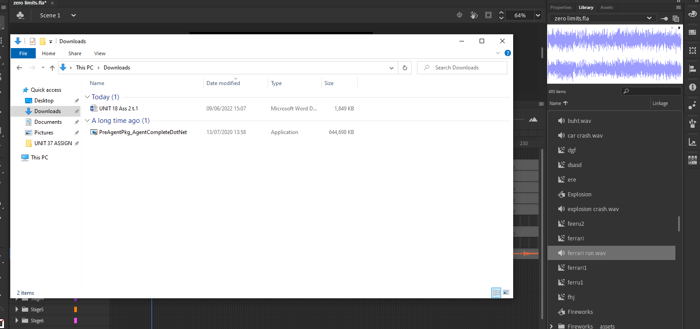

1. Then, select the frame where you want to add the sound, and head onto the “Properties” tab. In the following tab, go to the “Frame” section, and into the “Sound” area, select the audio you want to input and insert it into the animation.

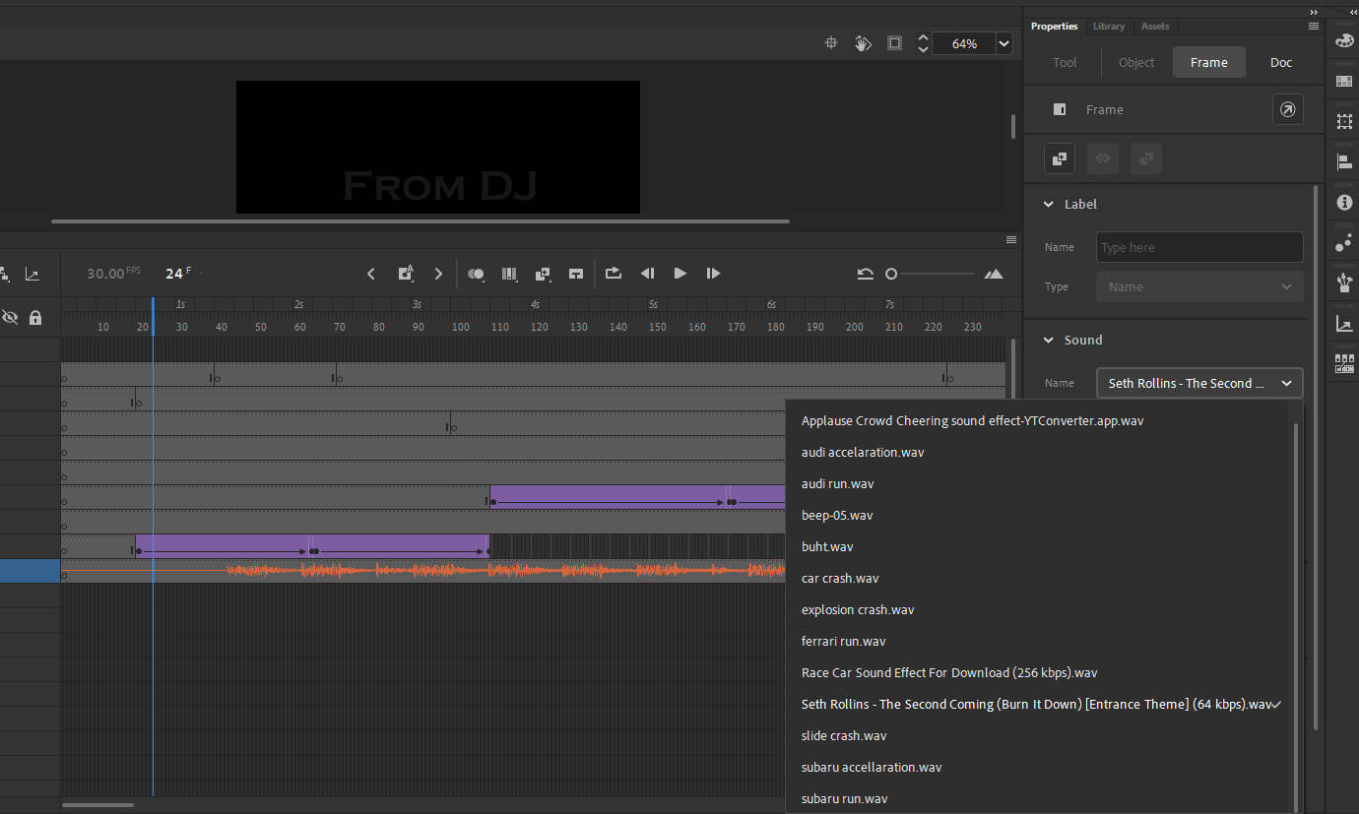

To start with the first stage of the animation, here are the following steps and procedures that bring a successful development to the first stage:

1. To start-off with the following stage, insert the backbone that defines the stage, which is the background to the animation. Firstly, create a layer inside the folder of the stage and from the file explorer or using any external source, insert the image to the canvas, scale it as according to the size of the canvas and position it in order for it to completely fill out the canvas as so:

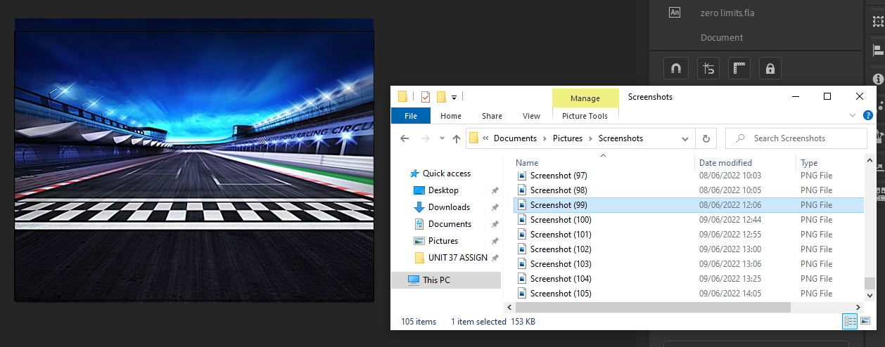

1. For each car, create different layers of the folders inside the stage that correspond to each car, and in each of these layers, add the image of the cars best suitable for the stage as so:

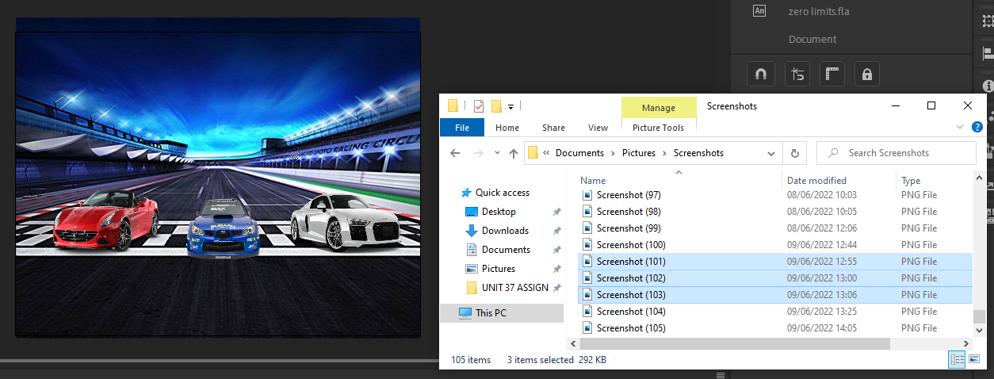

1. For the movement, add classic tween and extend its frame to at least 2 second frame. And in the end-point of the classic tween, drag the asset where you want to position after a certain time has been encountered, and scale its accordingly, so the perspective values have been respected to the viewer, since further an object is to the field of view of the viewer, the smaller it is, and vice versa.

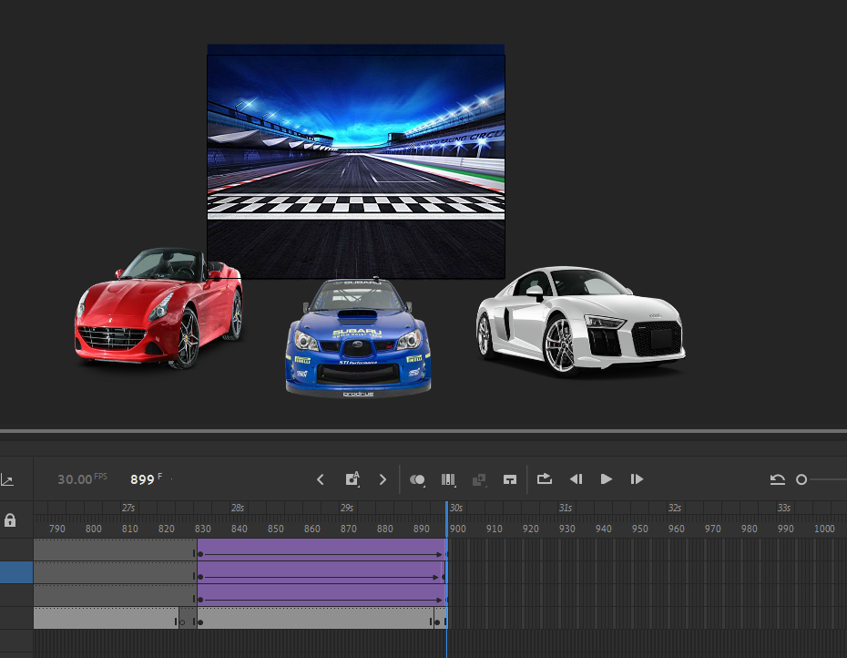

1. To add sound to the cars, create additional frames corresponding to the sound of the cars, and following the steps conducted above on how to add sound to the animation, add the sound to the frames as so. Firstly, open the “Library” tab of the top-right corner, and using file explorer, drag and drop the sound file into the library as so:

Then, select the frame where you want to add the sound, and head onto the “Properties” tab. In the following tab, go to the “Frame” section, and into the “Sound” area, select the audio you want to input and insert it into the animation.



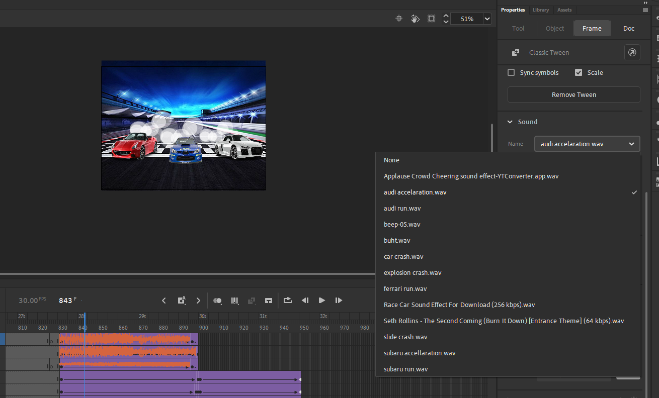

1. To add smoke trail to the stage, create new layers where you want to apply the smoke trail. And then from file explorer or any other sufficient importing tool, insert the smoke trail into the animation. Using classic tween, adjust the smoke trail to the cars and make a follow-up effect to the cars. Adjust the smoke trails according to the perspective and point of view values inside the animation. Here are how the end result looks:

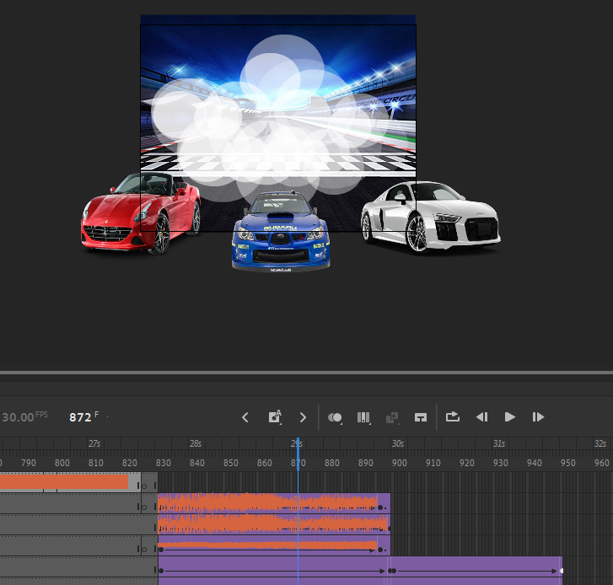

To start with the second stage of the animation, here are the following steps and procedures that bring a successful development to the second stage:

1. To start-off with the following stage, insert the backbone that defines the stage, which is the background to the animation. Firstly, create a layer inside the folder of the stage and from the file explorer or using any external source, insert the image to the canvas, scale it as according to the size of the canvas and position it in order for it to completely fill out the canvas as so:

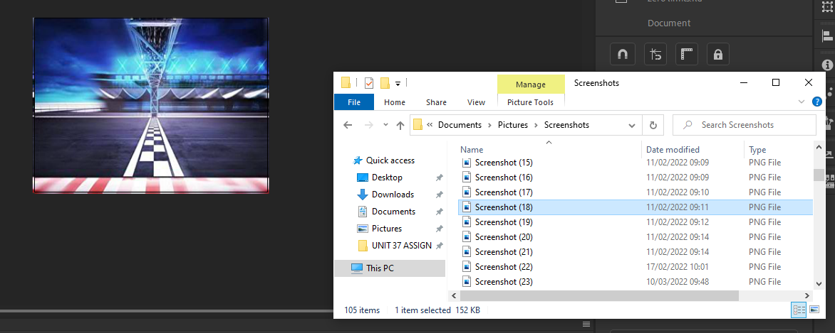

1. For each car, create different layers of the folders inside the stage that correspond to each car, and in each of these layers, add the image of the cars best suitable for the stage as so:

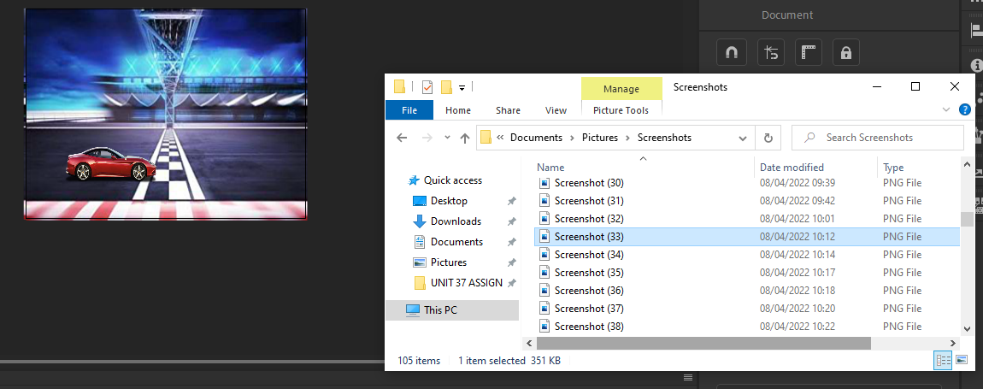

1. For the movement, add classic tween and extend its frame to at least 2 second frame. And in the end-point of the classic tween, drag the asset where you want to position after a certain time has been encountered, and scale its accordingly, so the perspective values have been respected to the viewer, since further an object is to the field of view of the viewer, the smaller it is, and vice versa.

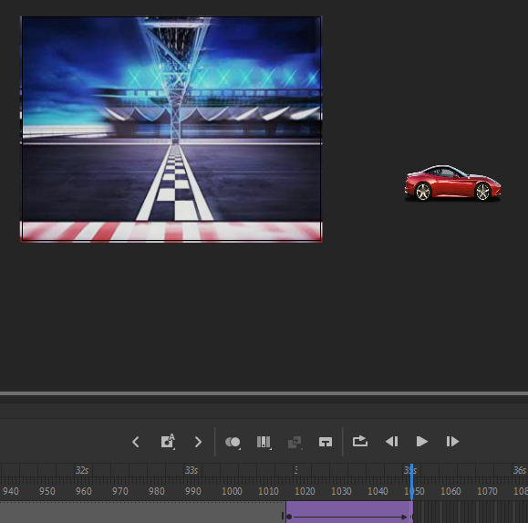

1. To add sound to the cars, create additional frames corresponding to the sound of the cars, and following the steps conducted above on how to add sound to the animation, add the sound to the frames as so. Firstly, open the “Library” tab of the top-right corner, and using file explorer, drag and drop the sound file into the library as so:

Then, select the frame where you want to add the sound, and head onto the “Properties” tab. In the following tab, go to the “Frame” section, and into the “Sound” area, select the audio you want to input and insert it into the animation.



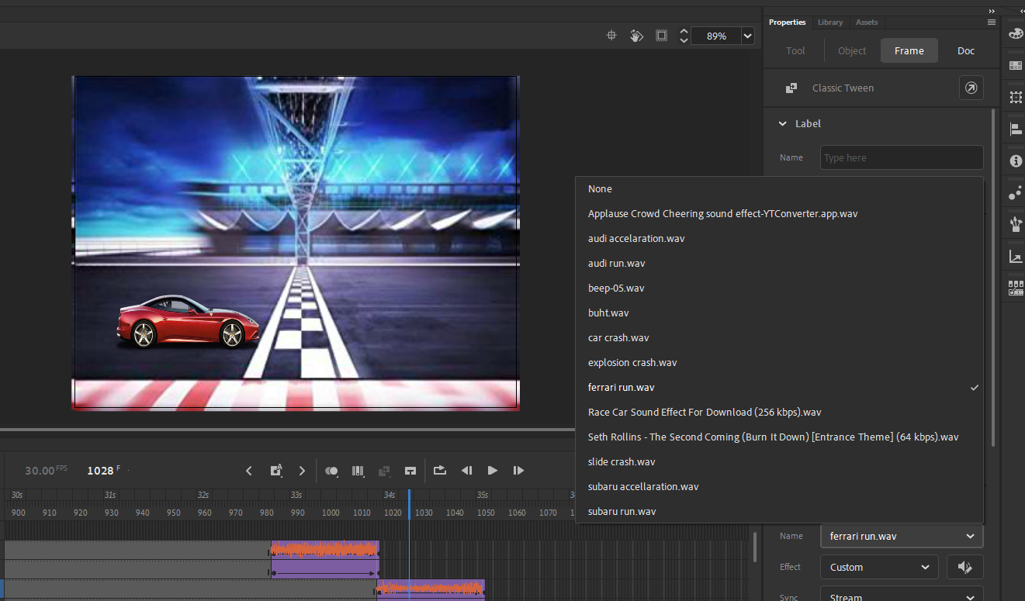

1. To add smoke trail to the stage, create new layers where you want to apply the smoke trail. And then from file explorer or any other sufficient importing tool, insert the smoke trail into the animation. Using classic tween, adjust the smoke trail to the cars and make a follow-up effect to the cars. Adjust the smoke trails according to the perspective and point of view values inside the animation. Here are how the end result looks:

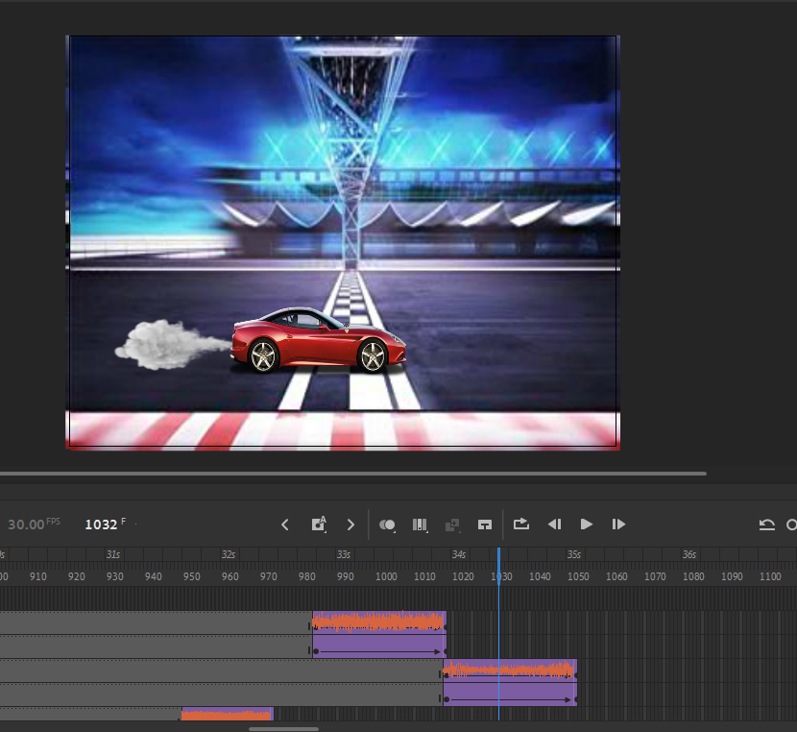



To start with the third stage of the animation, here are the following steps and procedures that bring a successful development to the third stage:

1. To start-off with the following stage, insert the backbone that defines the stage, which is the background to the animation. Firstly, create a layer inside the folder of the stage and from the file explorer or using any external source, insert the image to the canvas, scale it as according to the size of the canvas and position it in order for it to completely fill out the canvas as so:

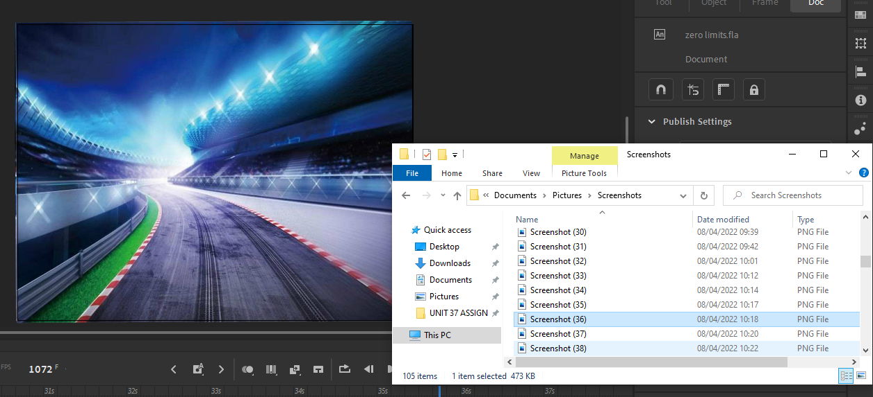

1. For each car, create different layers of the folders inside the stage that correspond to each car, and in each of these layers, add the image of the cars best suitable for the stage as so:

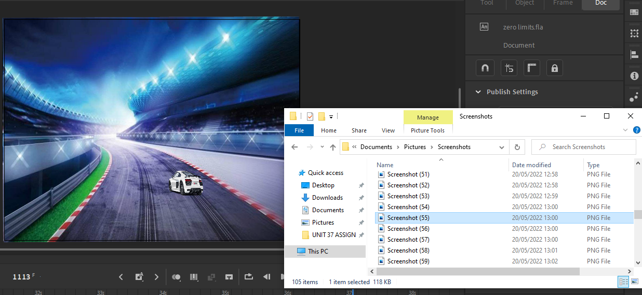

1. For the movement, add classic tween and extend its frame to at least 2 second frame. And in the end-point of the classic tween, drag the asset where you want to position after a certain time has been encountered, and scale its accordingly, so the perspective values have been respected to the viewer, since further an object is to the field of view of the viewer, the smaller it is, and vice versa.

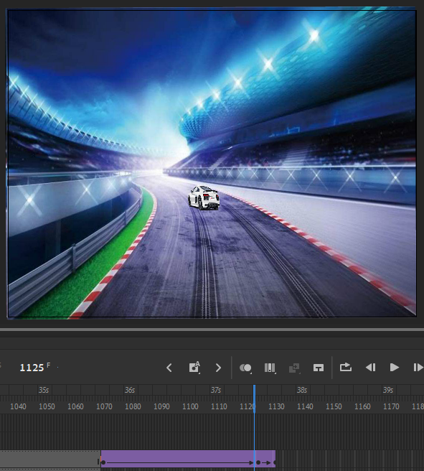

1. To add sound to the cars, create additional frames corresponding to the sound of the cars, and following the steps conducted above on how to add sound to the animation, add the sound to the frames as so. Firstly, open the “Library” tab of the top-right corner, and using file explorer, drag and drop the sound file into the library as so:

Then, select the frame where you want to add the sound, and head onto the “Properties” tab. In the following tab, go to the “Frame” section, and into the “Sound” area, select the audio you want to input and insert it into the animation.



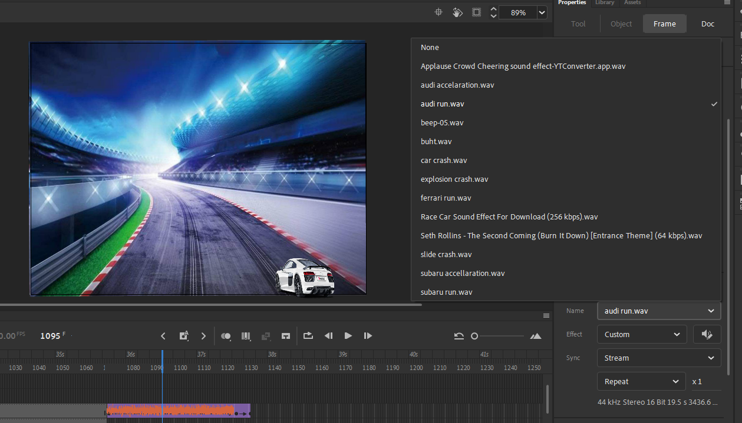

To start with the fourth stage of the animation, here are the following steps and procedures that bring a successful development to the fourth stage:

1. To start-off with the following stage, insert the backbone that defines the stage, which is the background to the animation. Firstly, create a layer inside the folder of the stage and from the file explorer or using any external source, insert the image to the canvas, scale it as according to the size of the canvas and position it in order for it to completely fill out the canvas as so:

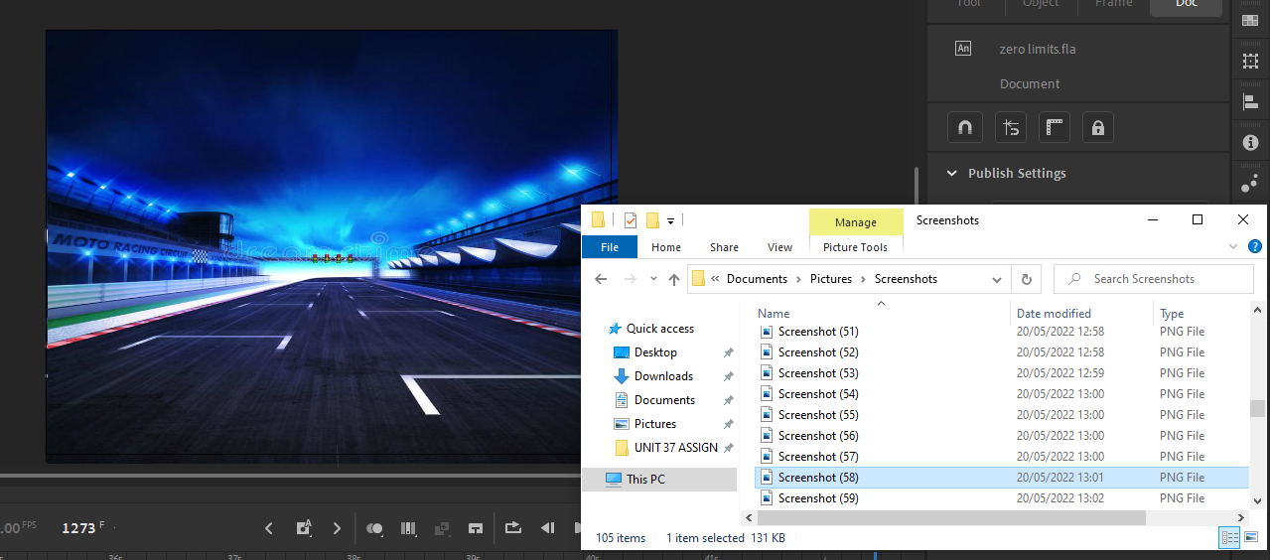

1. For each car, create different layers of the folders inside the stage that correspond to each car, and in each of these layers, add the image of the cars best suitable for the stage as so:

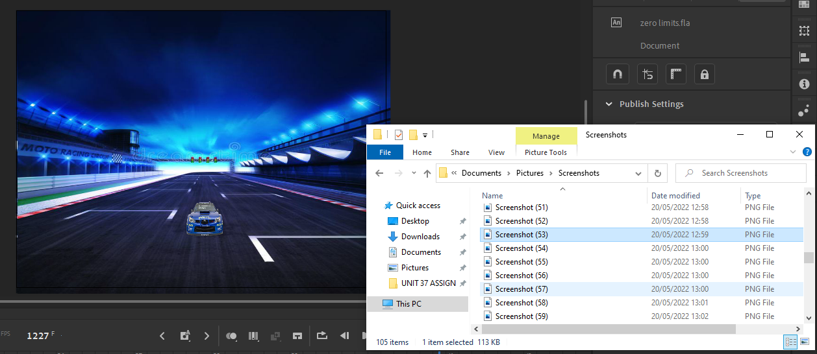

1. For the movement, add classic tween and extend its frame to at least 2 second frame. And in the end-point of the classic tween, drag the asset where you want to position after a certain time has been encountered, and scale its accordingly, so the perspective values have been respected to the viewer, since further an object is to the field of view of the viewer, the smaller it is, and vice versa.

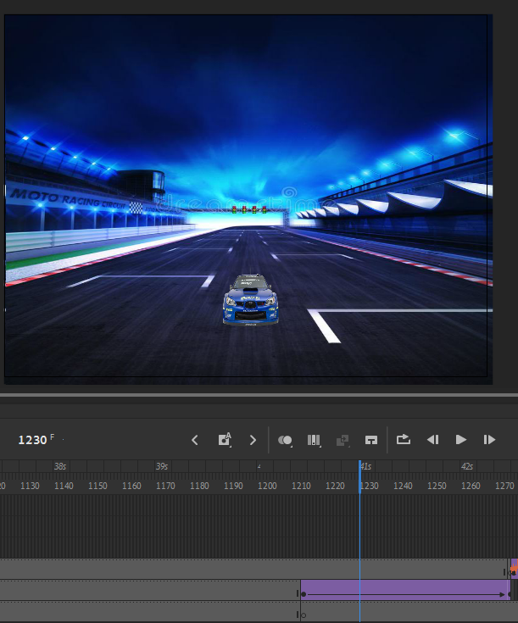

1. To add sound to the cars, create additional frames corresponding to the sound of the cars, and following the steps conducted above on how to add sound to the animation, add the sound to the frames as so. Firstly, open the “Library” tab of the top-right corner, and using file explorer, drag and drop the sound file into the library as so:

Then, select the frame where you want to add the sound, and head onto the “Properties” tab. In the following tab, go to the “Frame” section, and into the “Sound” area, select the audio you want to input and insert it into the animation.



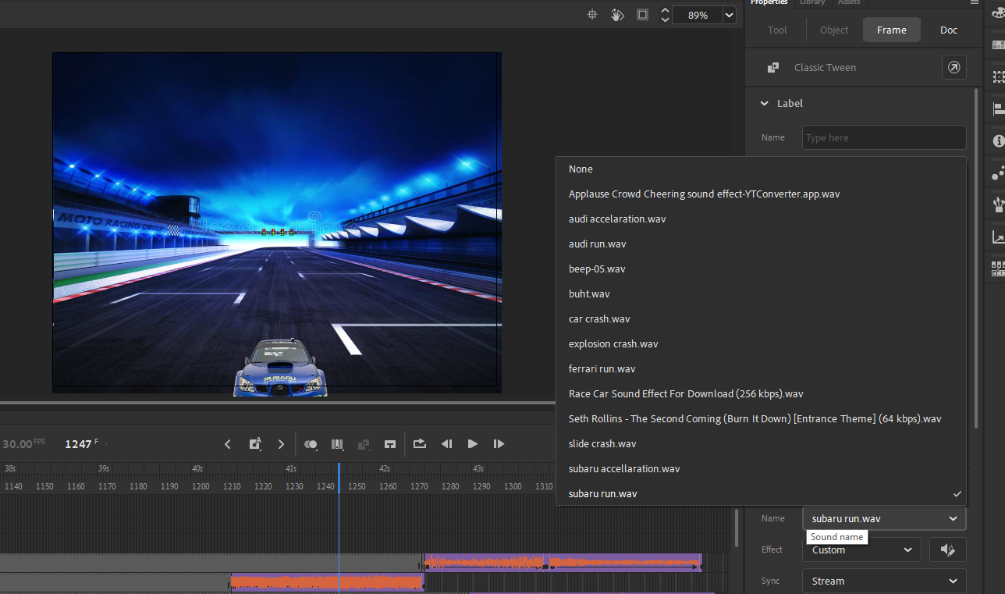

To start with the fifth stage of the animation, here are the following steps and procedures that bring a successful development to the fifth stage:

1. To start-off with the following stage, insert the backbone that defines the stage, which is the background to the animation. Firstly, create a layer inside the folder of the stage and from the file explorer or using any external source, insert the image to the canvas, scale it as according to the size of the canvas and position it in order for it to completely fill out the canvas as so:

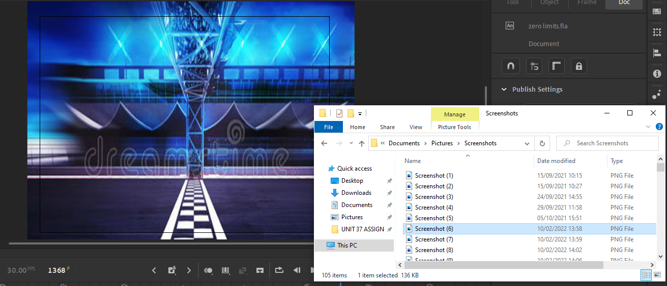

1. For each car, create different layers of the folders inside the stage that correspond to each car, and in each of these layers, add the image of the cars best suitable for the stage as so:

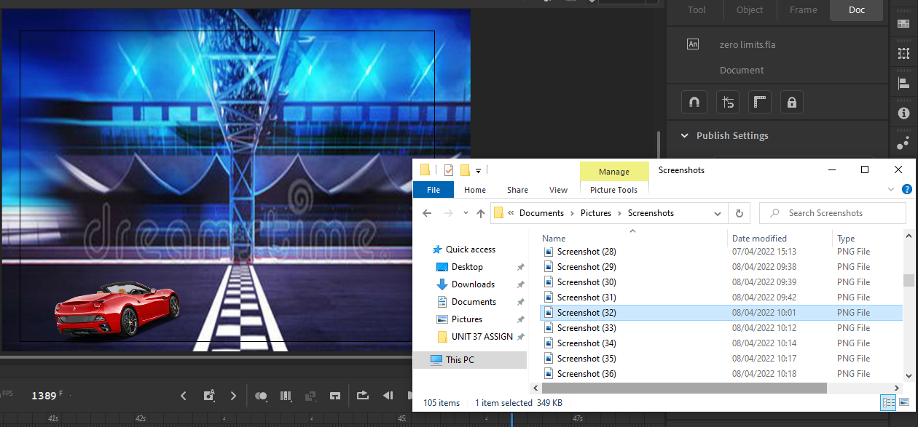

1. For the movement, add classic tween and extend its frame to at least 2 second frame. And in the end-point of the classic tween, drag the asset where you want to position after a certain time has been encountered, and scale its accordingly, so the perspective values have been respected to the viewer, since further an object is to the field of view of the viewer, the smaller it is, and vice versa.

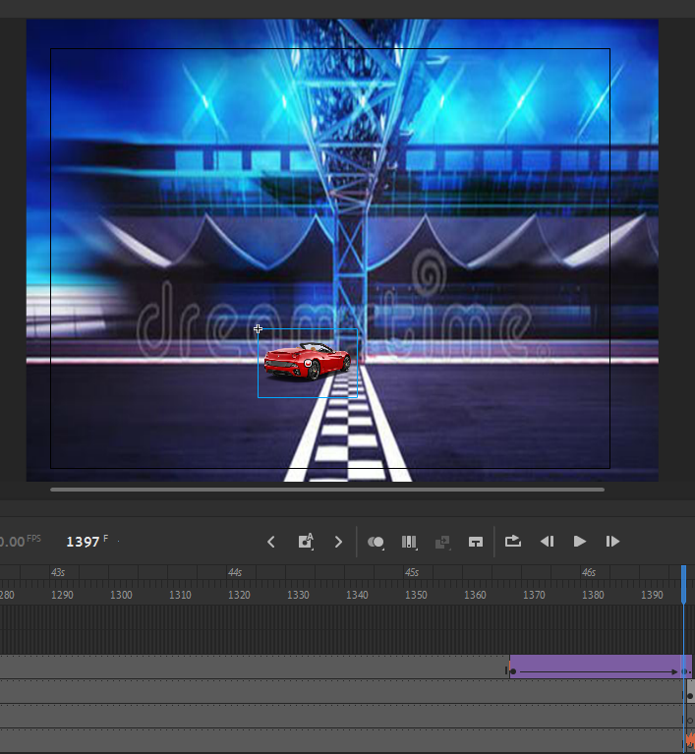

1. To add sound to the cars, create additional frames corresponding to the sound of the cars, and following the steps conducted above on how to add sound to the animation, add the sound to the frames as so. Firstly, open the “Library” tab of the top-right corner, and using file explorer, drag and drop the sound file into the library as so:

Then, select the frame where you want to add the sound, and head onto the “Properties” tab. In the following tab, go to the “Frame” section, and into the “Sound” area, select the audio you want to input and insert it into the animation.



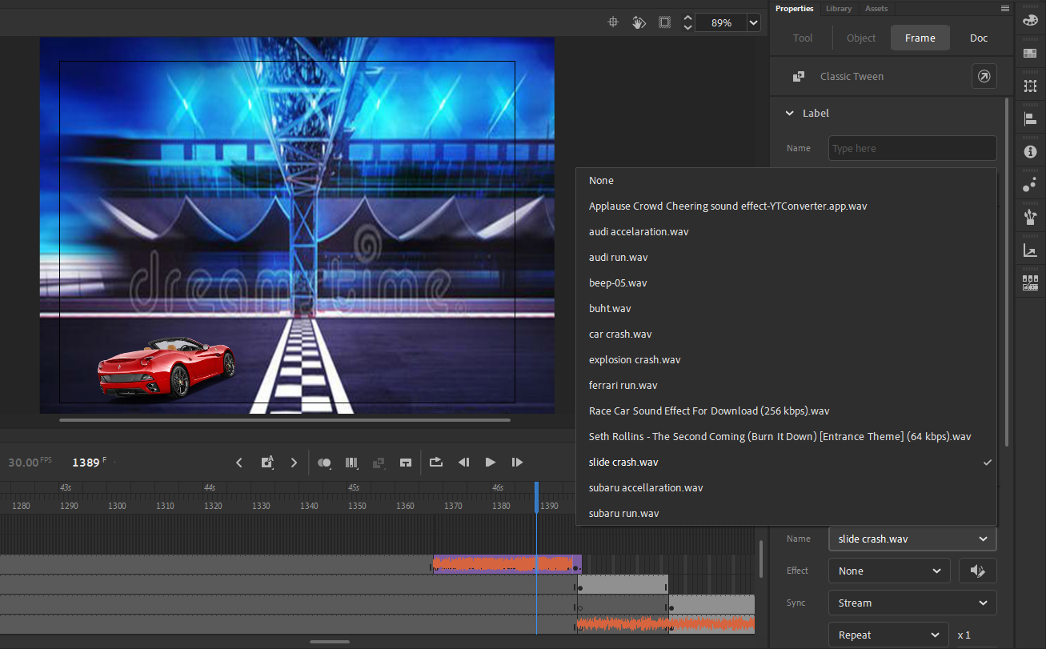

1. To add special effects to the stage, create new layers where you want to apply the special effects. And then from file explorer or any other sufficient importing tool, insert the special effects into the animation. Using classic tween, adjust the special effects to the cars and make a follow-up effect to the cars. Adjust the special effects according to the perspective and point of view values inside the animation. Here are how the end result looks:

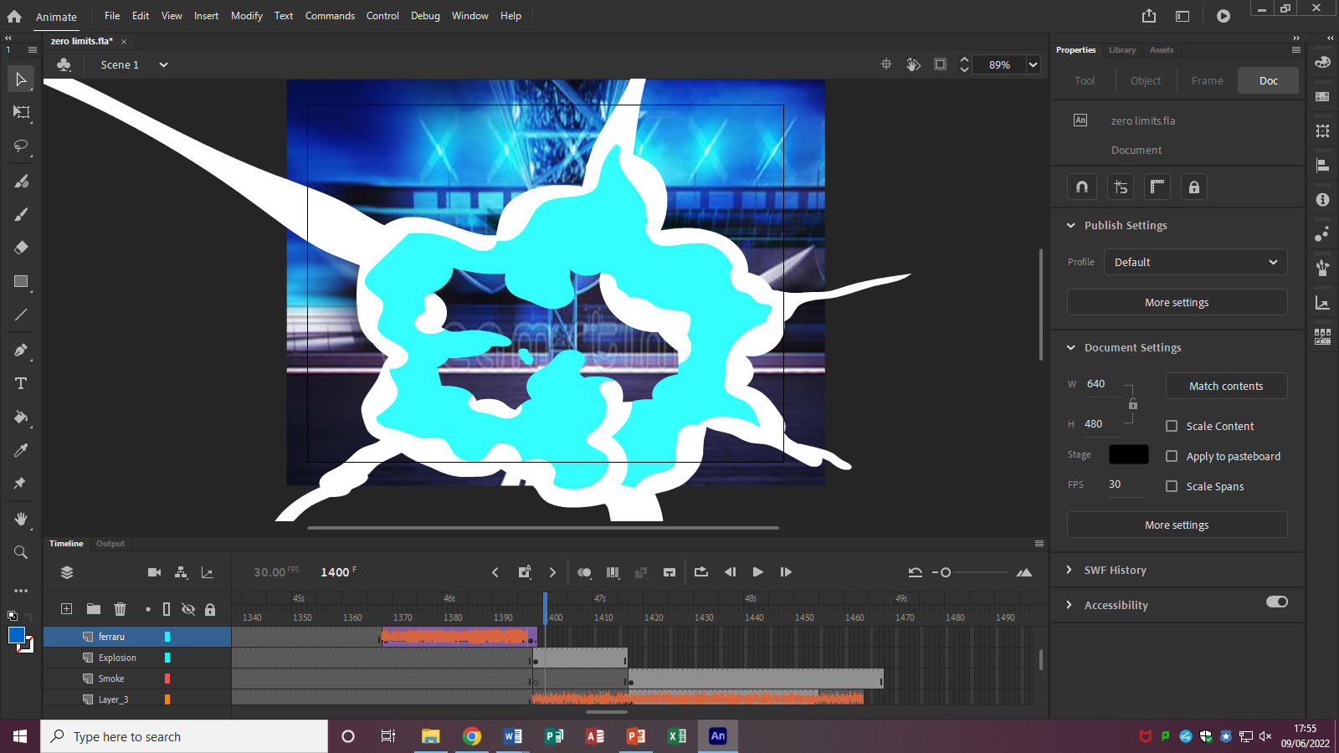

To start with the seventh stage of the animation, here are the following steps and procedures that bring a successful development to the seventh stage:

1. To start-off with the following stage, insert the backbone that defines the stage, which is the background to the animation. Firstly, create a layer inside the folder of the stage and from the file explorer or using any external source, insert the image to the canvas, scale it as according to the size of the canvas and position it in order for it to completely fill out the canvas as so:

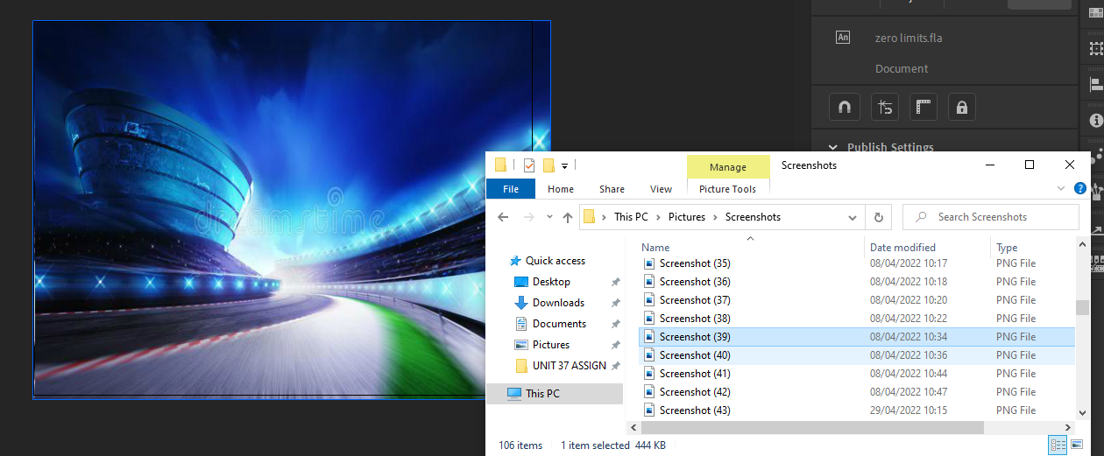

1. For each car, create different layers of the folders inside the stage that correspond to each car, and in each of these layers, add the image of the cars best suitable for the stage as so:

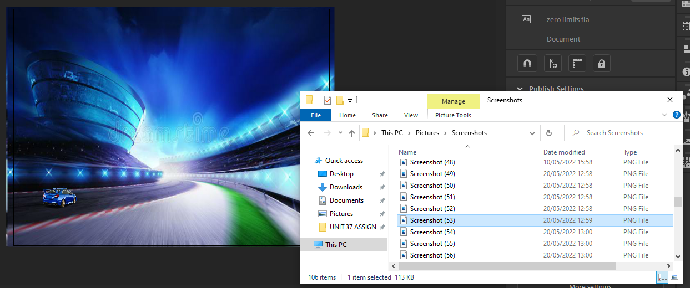

1. For the movement, add classic tween and extend its frame to at least 2 second frame. And in the end-point of the classic tween, drag the asset where you want to position after a certain time has been encountered, and scale its accordingly, so the perspective values have been respected to the viewer, since further an object is to the field of view of the viewer, the smaller it is, and vice versa.

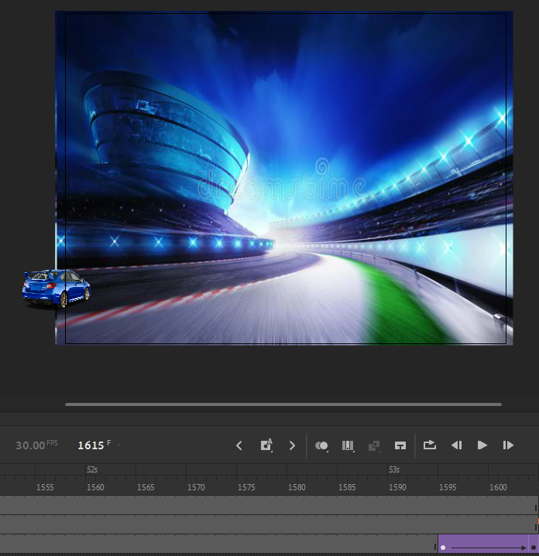

1. To add sound to the cars, create additional frames corresponding to the sound of the cars, and following the steps conducted above on how to add sound to the animation, add the sound to the frames as so. Firstly, open the “Library” tab of the top-right corner, and using file explorer, drag and drop the sound file into the library as so:

Then, select the frame where you want to add the sound, and head onto the “Properties” tab. In the following tab, go to the “Frame” section, and into the “Sound” area, select the audio you want to input and insert it into the animation.



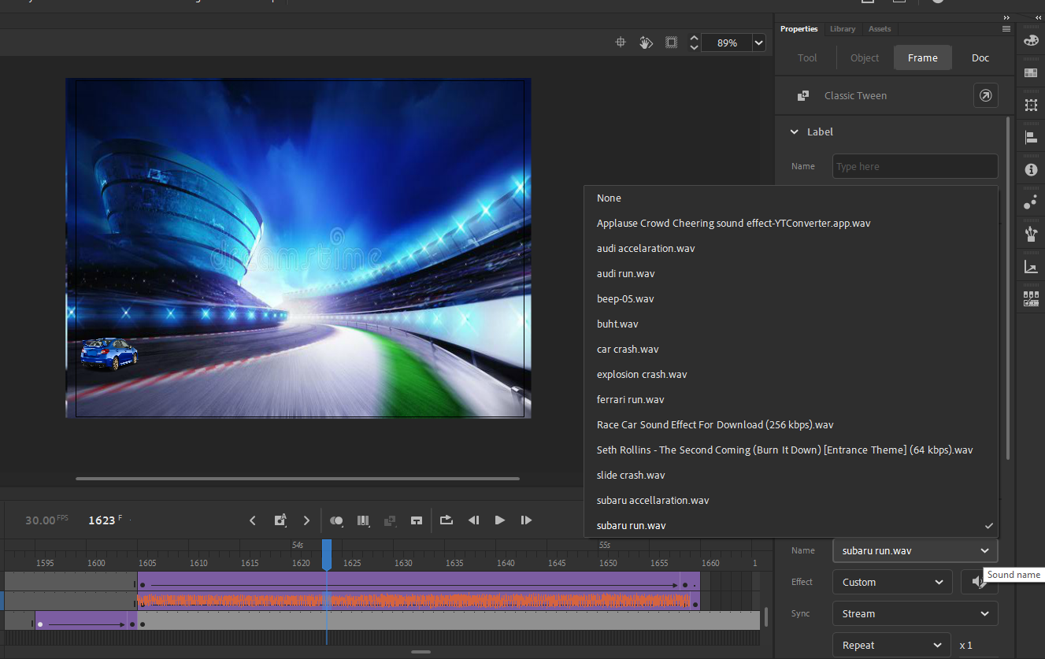

1. To add smoke trail to the stage, create new layers where you want to apply the smoke trail. And then from file explorer or any other sufficient importing tool, insert the smoke trail into the animation. Using classic tween, adjust the smoke trail to the cars and make a follow-up effect to the cars. Adjust the smoke trail according to the perspective and point of view values inside the animation. Here are how the end result looks:

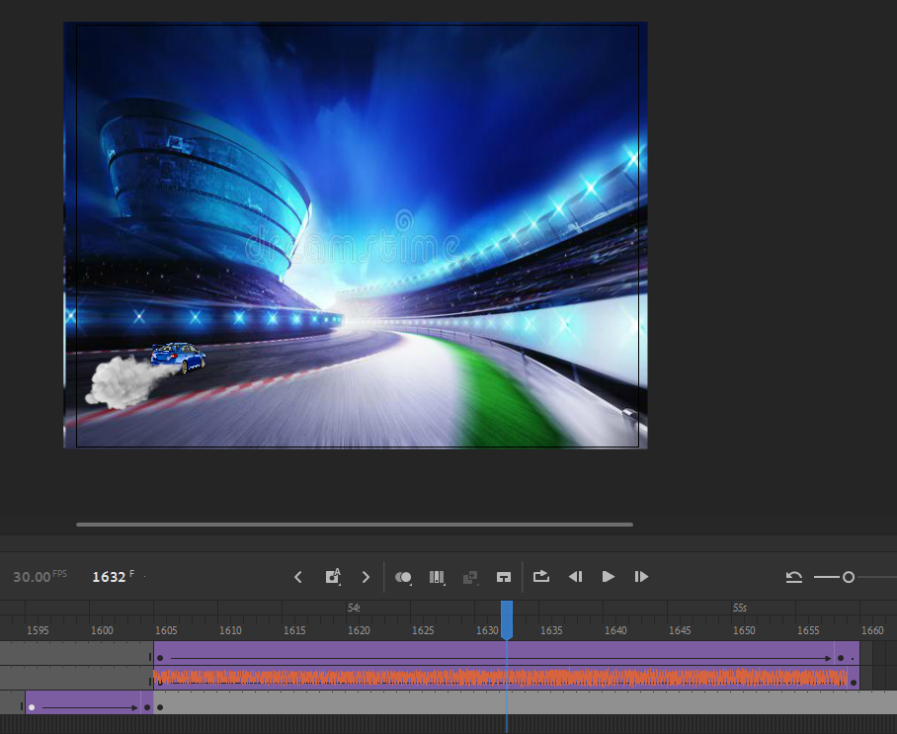

To start with the eighth stage of the animation, here are the following steps and procedures that bring a successful development to the eighth stage:

1. To start-off with the following stage, insert the backbone that defines the stage, which is the background to the animation. Firstly, create a layer inside the folder of the stage and from the file explorer or using any external source, insert the image to the canvas, scale it as according to the size of the canvas and position it in order for it to completely fill out the canvas as so:

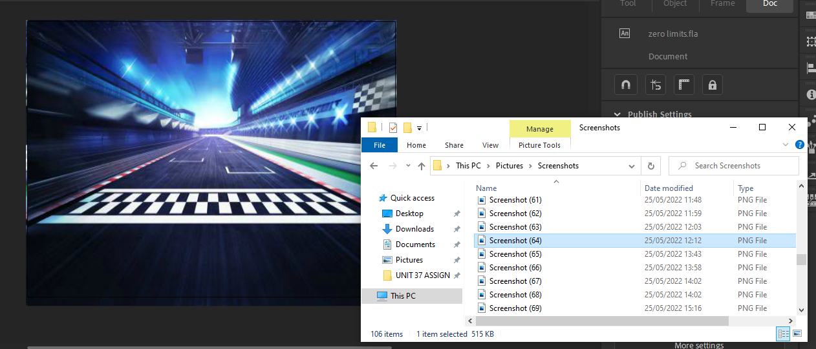

1. For each car, create different layers of the folders inside the stage that correspond to each car, and in each of these layers, add the image of the cars best suitable for the stage as so:

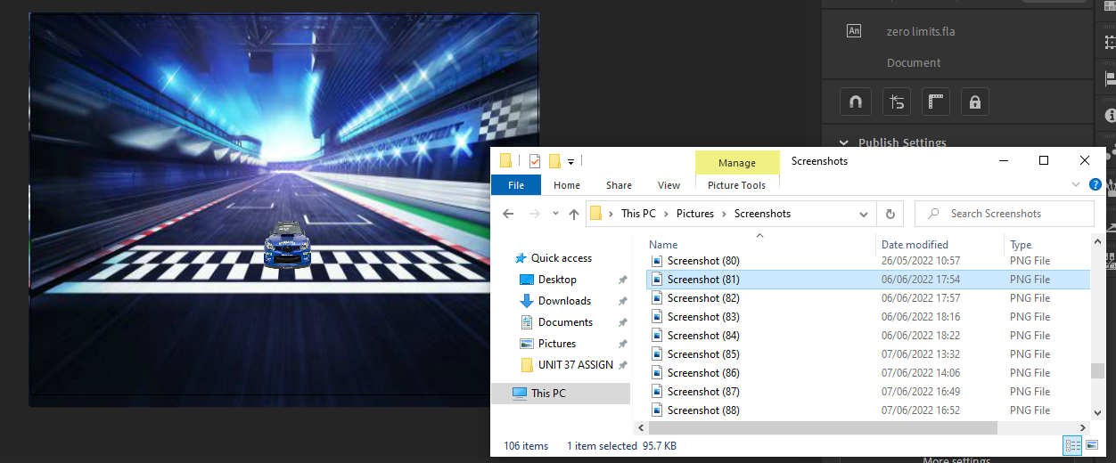

1. For the movement, add classic tween and extend its frame to at least 2 second frame. And in the end-point of the classic tween, drag the asset where you want to position after a certain time has been encountered, and scale its accordingly, so the perspective values have been respected to the viewer, since further an object is to the field of view of the viewer, the smaller it is, and vice versa.

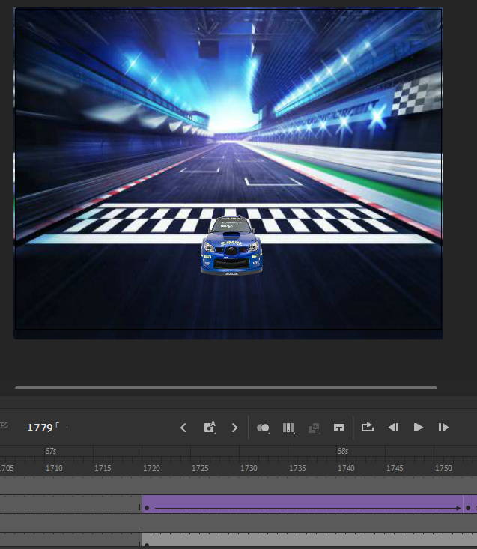

1. To add sound to the cars, create additional frames corresponding to the sound of the cars, and following the steps conducted above on how to add sound to the animation, add the sound to the frames as so. Firstly, open the “Library” tab of the top-right corner, and using file explorer, drag and drop the sound file into the library as so:

Then, select the frame where you want to add the sound, and head onto the “Properties” tab. In the following tab, go to the “Frame” section, and into the “Sound” area, select the audio you want to input and insert it into the animation.



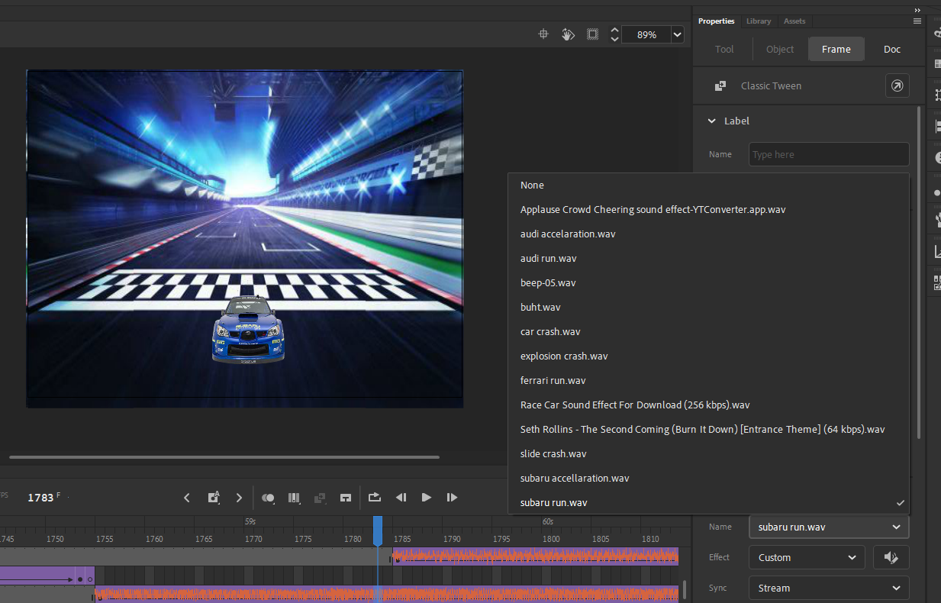

To start with the ninth stage of the animation, here are the following steps and procedures that bring a successful development to the ninth stage:

1. To start-off with the following stage, insert the backbone that defines the stage, which is the background to the animation. Firstly, create a layer inside the folder of the stage and from the file explorer or using any external source, insert the image to the canvas, scale it as according to the size of the canvas and position it in order for it to completely fill out the canvas as so:

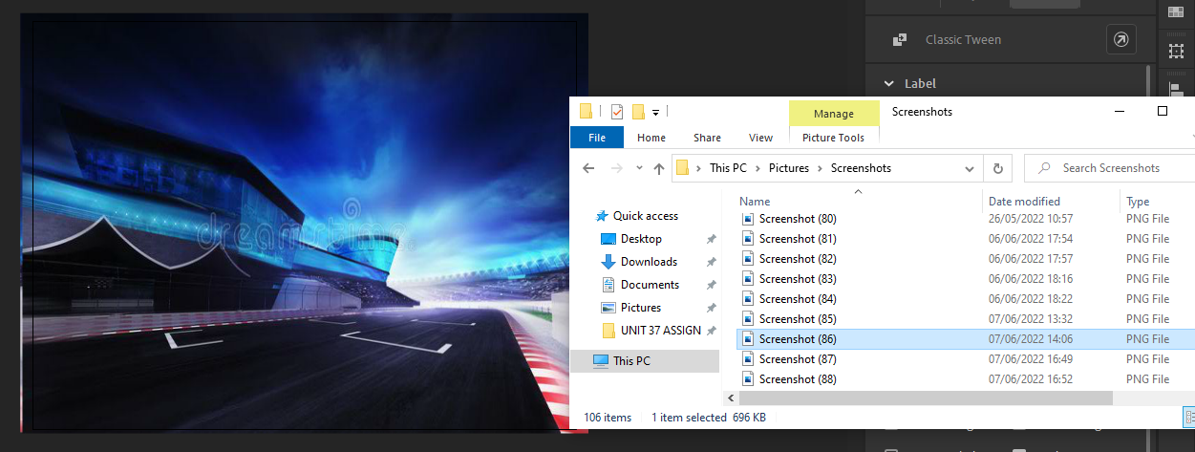

1. For each car, create different layers of the folders inside the stage that correspond to each car, and in each of these layers, add the image of the cars best suitable for the stage as so:

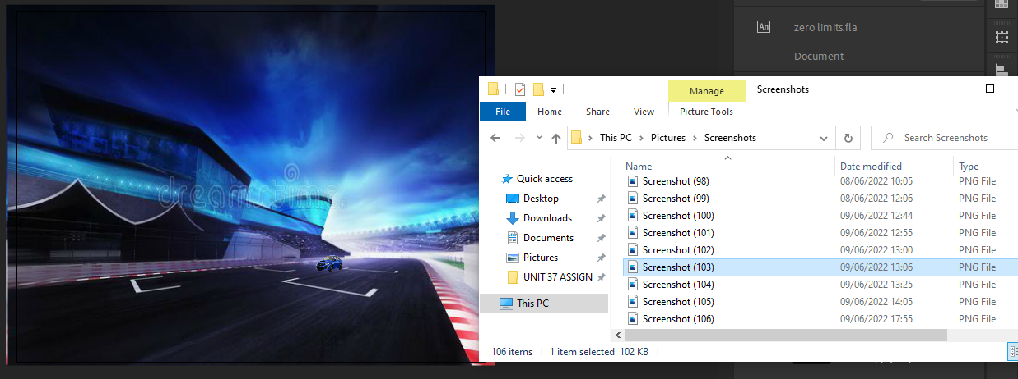

1. For the movement, add classic tween and extend its frame to at least 2 second frame. And in the end-point of the classic tween, drag the asset where you want to position after a certain time has been encountered, and scale its accordingly, so the perspective values have been respected to the viewer, since further an object is to the field of view of the viewer, the smaller it is, and vice versa.

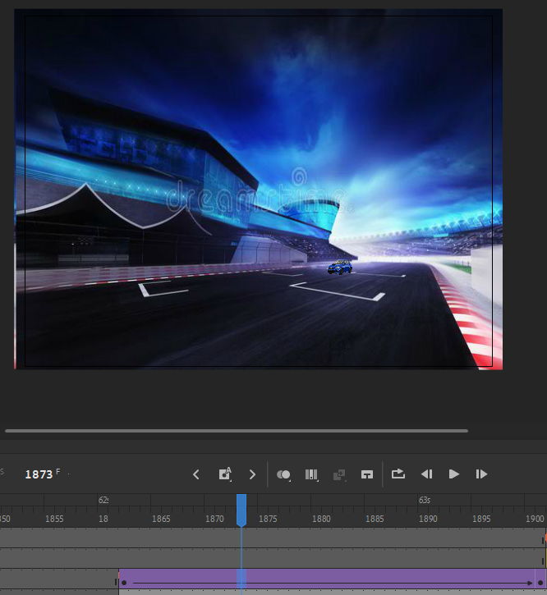

1. To add sound to the cars, create additional frames corresponding to the sound of the cars, and following the steps conducted above on how to add sound to the animation, add the sound to the frames as so. Firstly, open the “Library” tab of the top-right corner, and using file explorer, drag and drop the sound file into the library as so:

Then, select the frame where you want to add the sound, and head onto the “Properties” tab. In the following tab, go to the “Frame” section, and into the “Sound” area, select the audio you want to input and insert it into the animation.



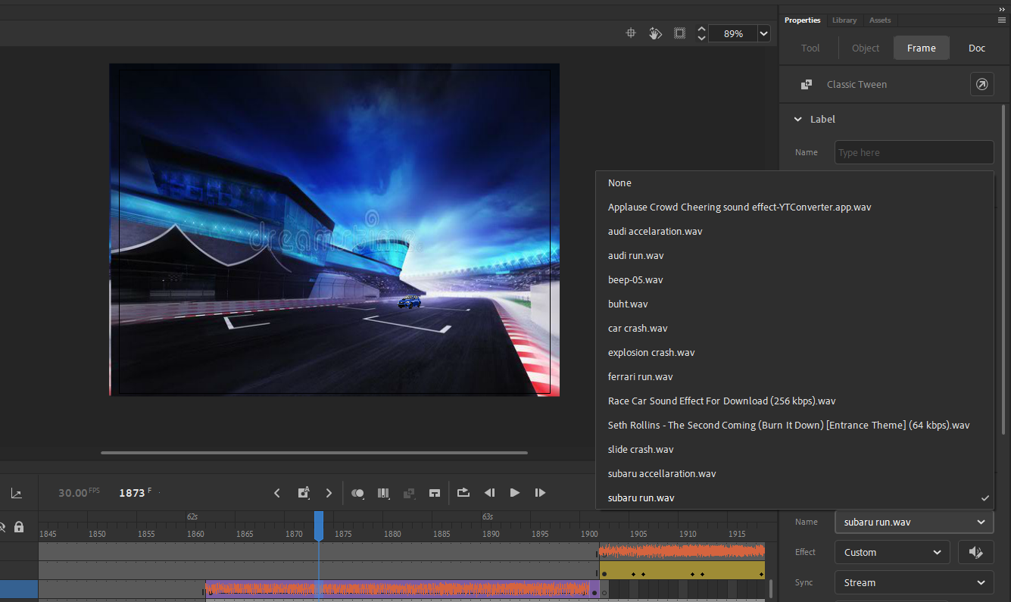

1. For advanced effects specific to the stage, I used the “Motion Tween”. Here is how I did this: First right click on the frame of the car, and select “Create Motion Tween” to insert and implement advanced movement functionalities. Then, charge the car’s image to output a rotating effect, which makes the car rotate as it goes through the barrier. This is the output of the effect:

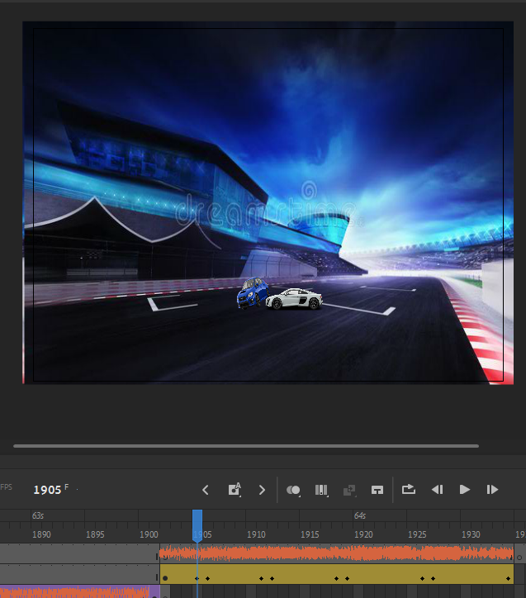

To start with the tenth stage of the animation, here are the following steps and procedures that bring a successful development to the tenth stage:

1. To start-off with the following stage, insert the backbone that defines the stage, which is the background to the animation. Firstly, create a layer inside the folder of the stage and from the file explorer or using any external source, insert the image to the canvas, scale it as according to the size of the canvas and position it in order for it to completely fill out the canvas as so:

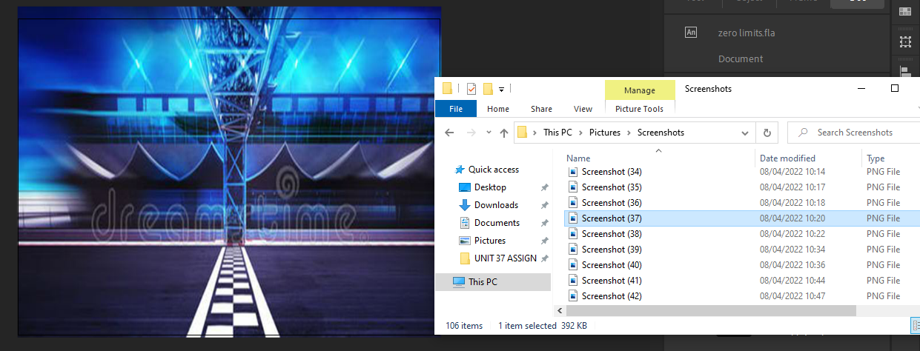

1. For each car, create different layers of the folders inside the stage that correspond to each car, and in each of these layers, add the image of the cars best suitable for the stage as so:

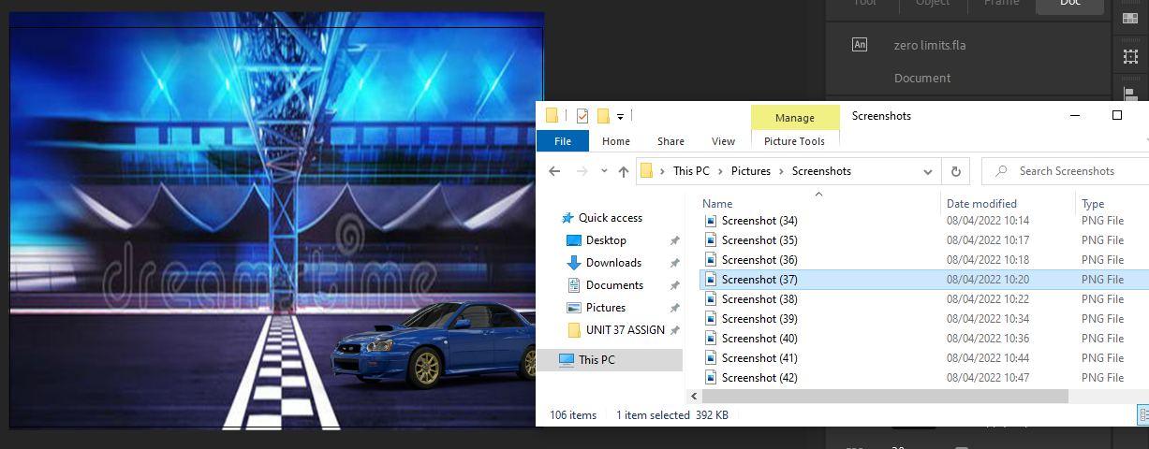

1. For advanced effects specific to the stage, I used the “Motion Tween”. Here is how I did this: First right click on the frame of the car, and select “Create Motion Tween” to insert and implement advanced movement functionalities. Then, charge the car’s image to output a rotating effect, which makes the car rotate as it goes through the barrier. This is the output of the effect:

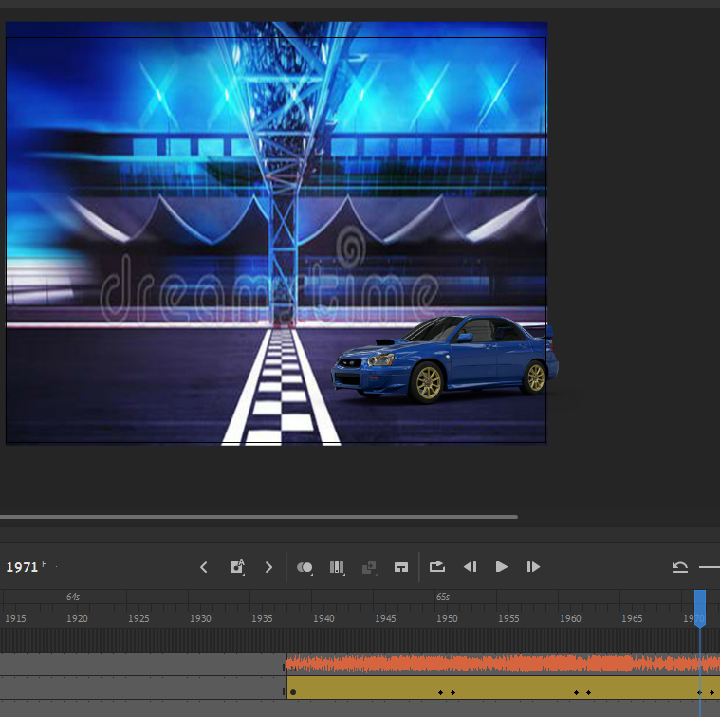

1. To add sound to the cars, create additional frames corresponding to the sound of the cars, and following the steps conducted above on how to add sound to the animation, add the sound to the frames as so. Firstly, open the “Library” tab of the top-right corner, and using file explorer, drag and drop the sound file into the library as so:

Then, select the frame where you want to add the sound, and head onto the “Properties” tab. In the following tab, go to the “Frame” section, and into the “Sound” area, select the audio you want to input and insert it into the animation.



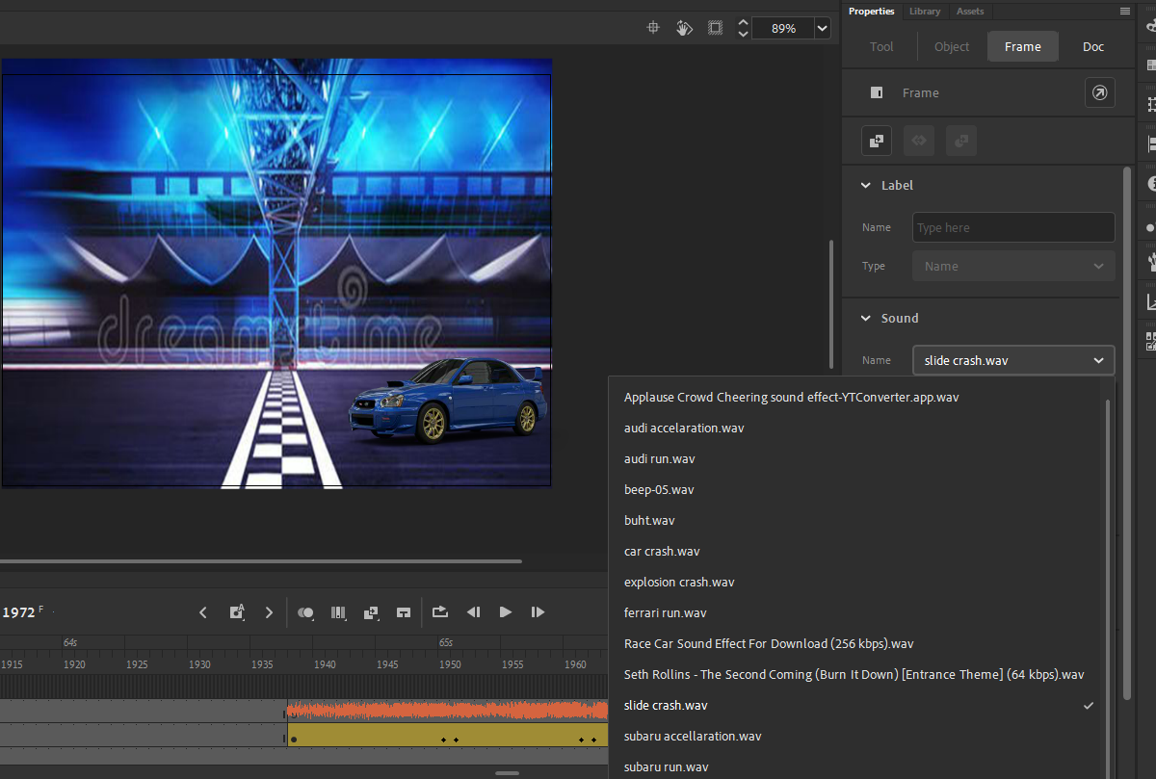

1. To add special effects to the stage, create new layers where you want to apply the special effects. And then from file explorer or any other sufficient importing tool, insert the special effects into the animation. Using classic tween, adjust the special effects to the cars and make a follow-up effect to the cars. Adjust the special effects according to the perspective and point of view values inside the animation. Here are how the end result looks:



To start with the eleventh stage of the animation, here are the following steps and procedures that bring a successful development to the eleventh stage:

1. To start-off with the following stage, insert the backbone that defines the stage, which is the background to the animation. Firstly, create a layer inside the folder of the stage and from the file explorer or using any external source, insert the image to the canvas, scale it as according to the size of the canvas and position it in order for it to completely fill out the canvas as so:

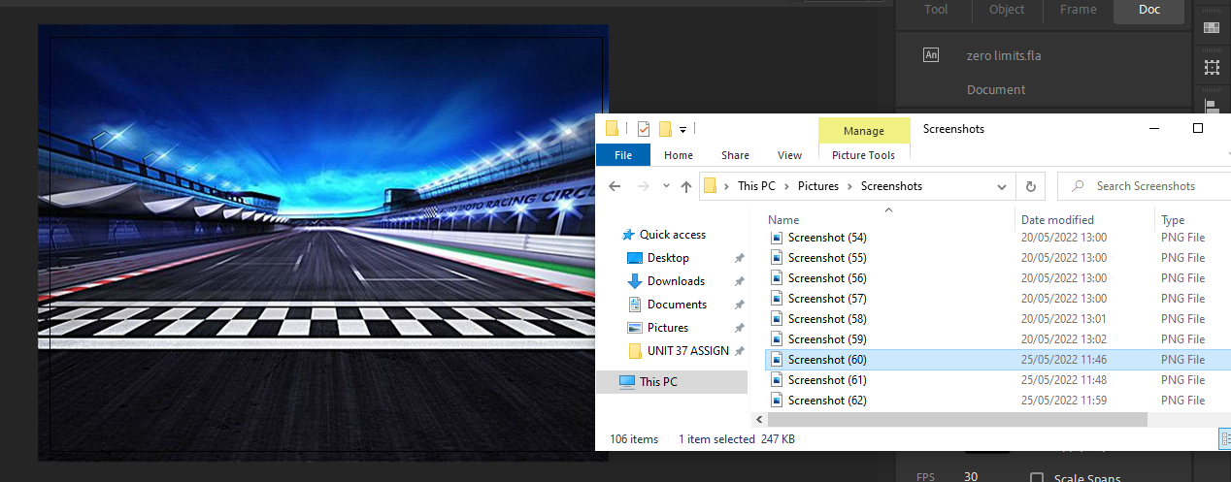

1. For each car, create different layers of the folders inside the stage that correspond to each car, and in each of these layers, add the image of the cars best suitable for the stage as so:

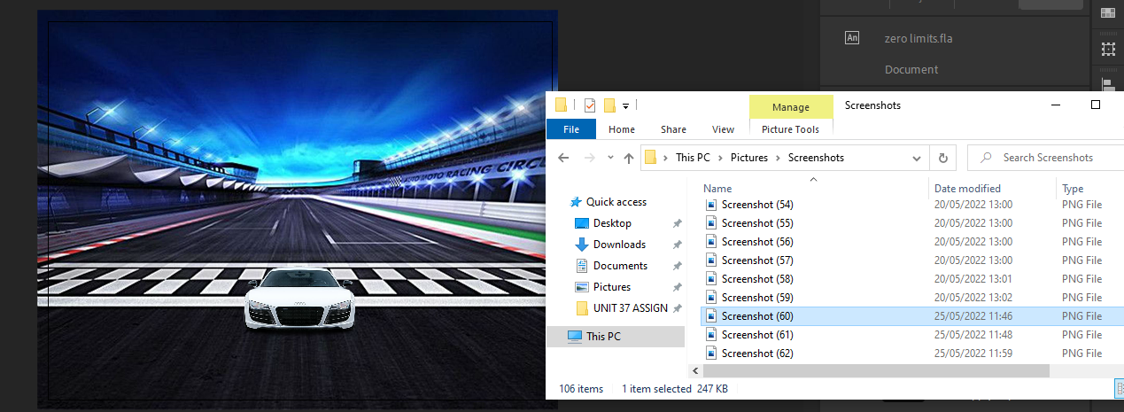

1. For advanced effects specific to the stage, I used the “Motion Tween”. Here is how I did this: First right click on the frame of the car, and select “Create Motion Tween” to insert and implement advanced movement functionalities. Then, charge the car’s image to output a rotating effect, which makes the car rotate as it goes through the barrier. This is the output of the effect:

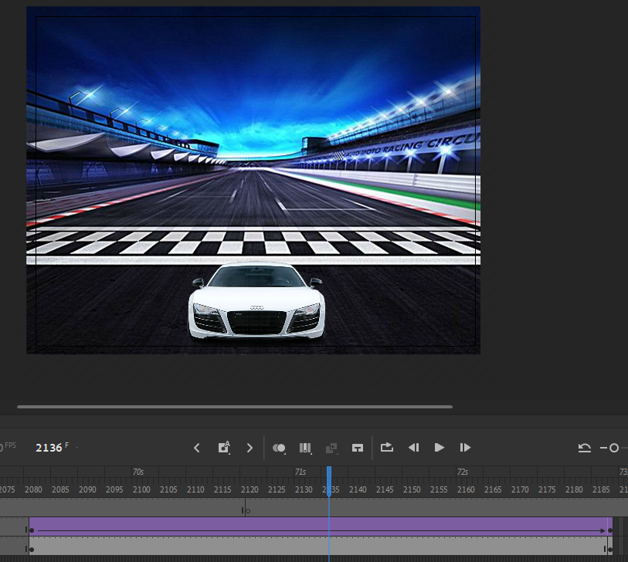

1. To add sound to the cars, create additional frames corresponding to the sound of the cars, and following the steps conducted above on how to add sound to the animation, add the sound to the frames as so. Firstly, open the “Library” tab of the top-right corner, and using file explorer, drag and drop the sound file into the library as so:

Then, select the frame where you want to add the sound, and head onto the “Properties” tab. In the following tab, go to the “Frame” section, and into the “Sound” area, select the audio you want to input and insert it into the animation.



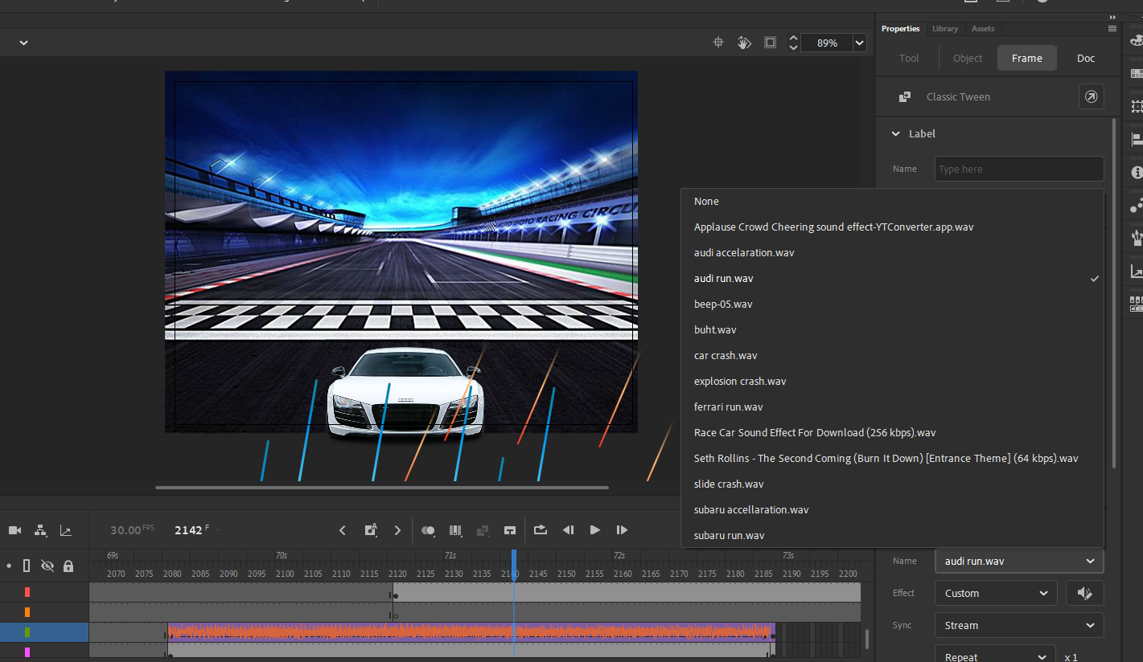

1. To add special effects to the stage, create new layers where you want to apply the special effects. And then from file explorer or any other sufficient importing tool, insert the special effects into the animation. Using classic tween, adjust the special effects to the cars and make a follow-up effect to the cars. Adjust the special effects according to the perspective and point of view values inside the animation. Here are how the end result looks:

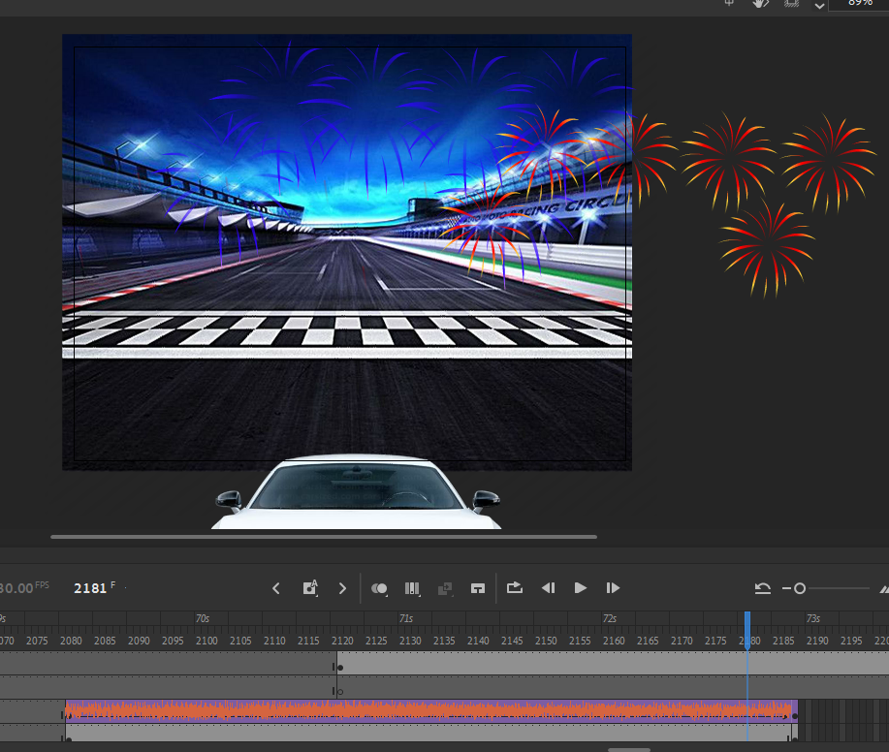

To start with the eleventh stage of the animation, here are the following steps and procedures that bring a successful development to the eleventh stage:

1. To start-off with the following stage, insert the backbone that defines the stage, which is the background to the animation. Firstly, create a layer inside the folder of the stage and from the file explorer or using any external source, insert the image to the canvas, scale it as according to the size of the canvas and position it in order for it to completely fill out the canvas as so:

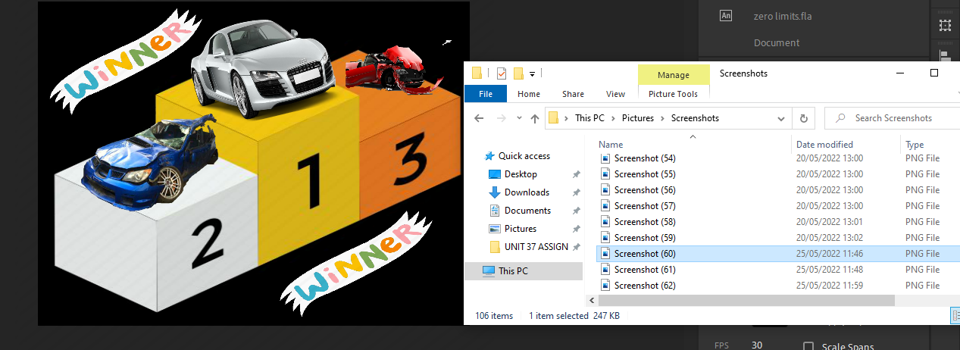

1. To add special effects to the stage, create new layers where you want to apply the special effects. And then from file explorer or any other sufficient importing tool, insert the special effects into the animation. Using classic tween, adjust the special effects to the cars and make a follow-up effect to the cars. Adjust the special effects according to the perspective and point of view values inside the animation. Here are how the end result looks:

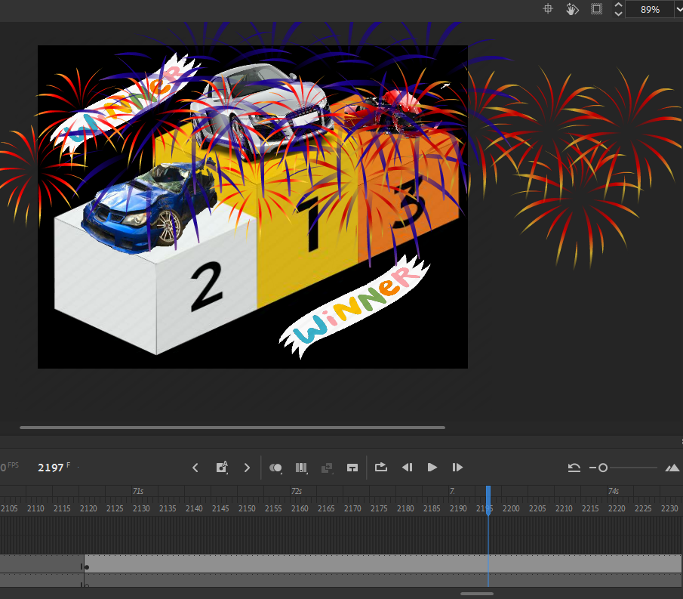

Finishing off with the following stage, my animation is ready. To export the animation into a video file, apply the following steps:

1. On the top-right far corner of the animation, select “Quick share and publish” button, which makes the animation to be exported into a .mov, .mp4 or .fla file format, which is utilized for the visualization of videos.

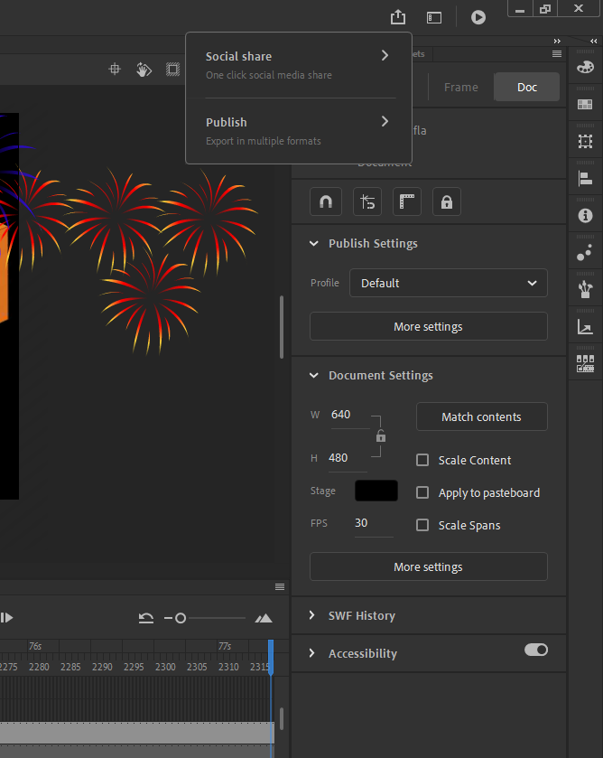

1. On the drop-down menu, click on the last option which is “Publish”.



1. In the “Publish” menu, click on the first option, which is the “Video (.mp4)” format, to export it as a movie file. And after finalizing the operation, click on “Publish”.

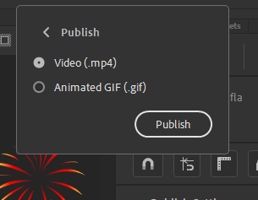

1. On the file explorer, the .mp4 file of the animation will get uploaded. And the animation will be ready to exhibit in any corner.

